

Requirement & Design Specification
Matching Tutor System (EDUFIT)
Version: 1.0

– DaNang, September 2026–

Contents
Record of Changes 2
I. Overview 4
1. User Requirements 4
1.1 Actors 4
1.2 Use Cases 4
2. Overall Functionalities 5
2.1 Screens Flow 5
2.2 Screen Descriptions 5
2.3 Screen Authorization 5
2.4 Non-UI Functions 6
3. System High Level Design 6
3.1 Database Design 6
3.2 Code Packages 7
II. Requirement Specifications 8
1. <<Feature Name>> 8
1.1 <<UseCaseCode_UC Name>> 8
2. Common Functions 11
2.1 UC-2_Login System 11
3. Patron Feature 12
3.1 UC-5_Order a Meal 12
3.2 UC-6_Register for Payroll Deduction 13
III. Design Specifications 14
1. <<Feature Name>> 14
1.1 <<SubFeature Name>> 14
1.2 System Access 15
IV. Appendix 19
1. Assumptions & Dependencies 19
2. Limitations & Exclusions 19
3. Business Rules 19
4. .. 19

I. Overview

1. Project Background & Product Perspective
Students commonly need external academic support, and their parents are typically the ones responsible for finding and vetting that support. The current market offers two paths, and both leave the same gap unaddressed:
- Traditional tutoring centers: Act as intermediaries. They take a cut of the fee and offer baseline vetting, but parents cannot independently verify a tutor's actual track record.
- Independent tech platforms: Reduce the interaction to a classified-ad model (post, contact, negotiate off-platform). The platform's involvement effectively ends once the match is made.
In both cases, once a tutor is engaged, there is no shared, structured record of the learning relationship (what was taught, student improvement, or arrangement sustainability).

1.1 Problem Statement
- From the Parent/Student side: Trust is hard to establish (claims are difficult to verify), and progress is invisible—most feedback is verbal, inconsistent, and lost between sessions.
- From the Tutor side: Finding students independently is difficult, and there is no neutral, portable way to accumulate a verifiable reputation or manage multiple students' progress in one place.

1.2 The EduFit Solution
EduFit exists to close this gap by treating tutor–student matching as the start of a tracked relationship rather than the end of a transaction. Rather than only helping a parent or student find a tutor, the platform provides both sides with a shared, ongoing, and data-driven record of the learning process, featuring:
- Goal Tracking: Stating and measuring progress against clear academic goals over time.
- Session Management: Shared schedules and structured session-level feedback.
- Objective Evaluation: Verifiable quiz results and performance data to answer "is this working?" objectively.

1.3 System Context

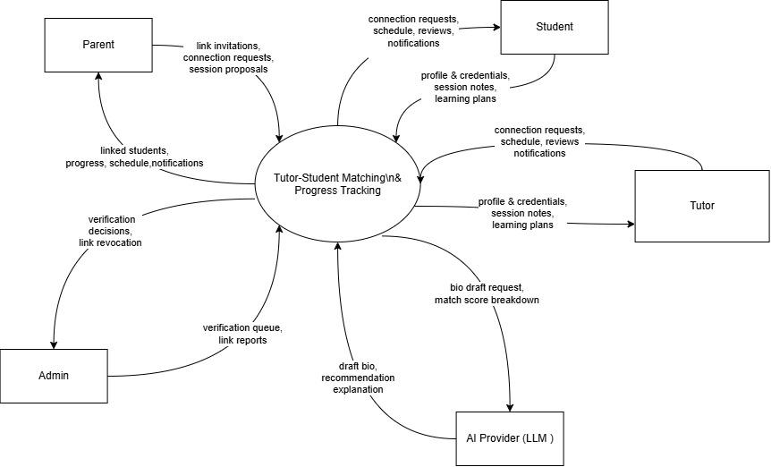

2. User Requirements

2.1 Actor

Actor | Type | Description
User | Abstract / Primary Actor | Any registered account holder. Specialized by Student, Parent, Tutor and Admin (registration, login, logout, password management)
Student | Primary Actor | The learner. Manages learning goals, discovers/matches tutors, sends connection requests, negotiates schedules, and tracks personal milestone progress.
Parent | Primary Actor | Links to students, searches tutors and requests connections on the student's behalf, manages session schedules, and tracks progress via single or multi-student dashboards.
Tutor | Primary Actor | Builds teaching profiles, submits credentials for verification, accepts connection requests, defines milestone-based learning plans, and records session outcomes.
Admin | Primary Actor | Reviews and approves tutor credentials, manages user accounts, resolves disputes, maintains system catalogs, and monitors platform/AI usage.
AI Provider / LLM Service | Secondary Actor (<>) | External LLM service providing draft tutor bios, verbalized recommendation explanations, and drafting assistance for quizzes and progress insights.

2.2 Diagram
Authentication

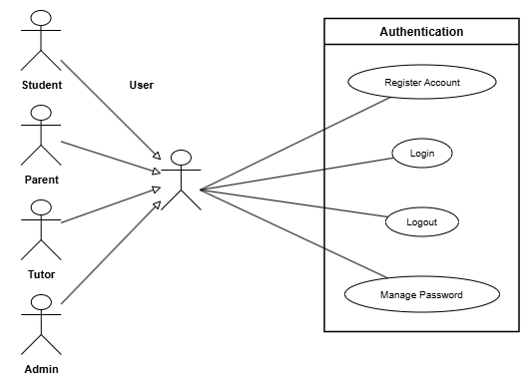

Profile Management 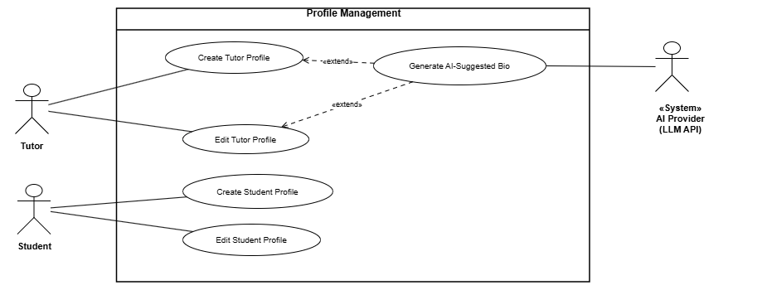

Tutor Verification
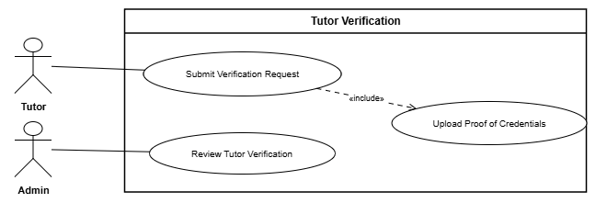

Tutor Discovery & Matching

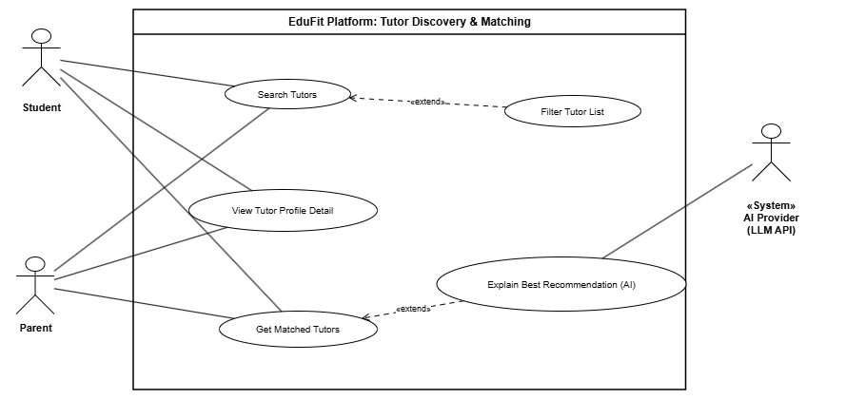

Link & Connection

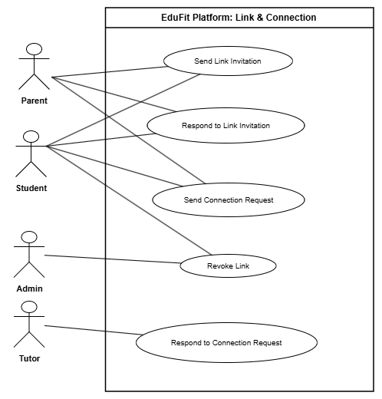

Scheduling & Session Lifecycle

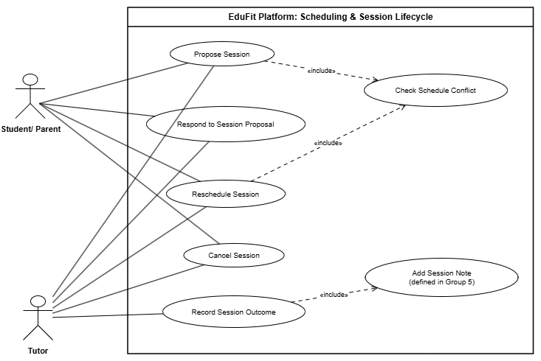

Learning Plan & Progress Tracking

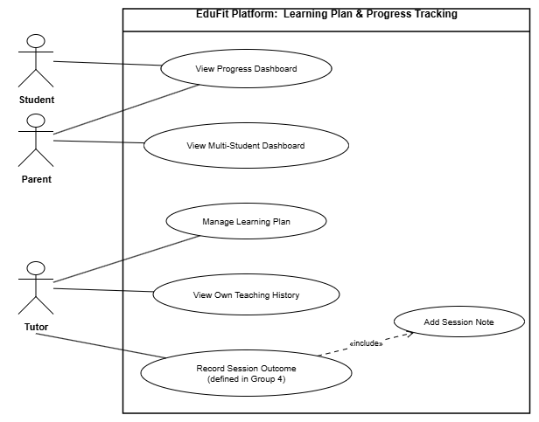

Review & Notification

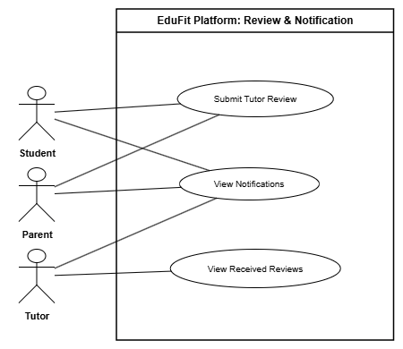

2.3 Descriptions

Group 1a — Authentication

UC ID | Use Case Name | Actor | Description
UC1.1 | Register Account | User (Student, Parent, Tutor) | Allows a visitor to create a role-specific account and complete mandatory email verification. (Admin accounts are provisioned separately).
UC1.2 | Login | User (Zalo supported for Student/Parent) | Authenticates credentials (email/password or Zalo OAuth) to establish a secure session and route to the correct landing view.
UC1.3 | Logout | User | Terminates the active session, invalidates tokens, and safely redirects to the public landing page.
UC1.4 | Manage Password | User | Enables users to retain account access via forgot-password email tokens, password resets, or changing passwords while logged in.

Group 1b — Profile Management

UC ID | Use Case Name | Actor | Description
UC1.5 | Create Tutor Profile | Tutor | Creates an initial teaching profile (subjects, grades, rates, availability, delivery mode, and teachable areas).
UC1.6 | Edit Tutor Profile | Tutor | Updates existing tutor teaching details, schedules, and rates; material changes may require re-verification.
UC1.7 | Generate AI-Suggested Bio | Primary: Tutor  Secondary: AI Provider (<>) | (<> UC1.5, UC1.6) AI drafts a bio from raw tutor inputs; the tutor must review, edit, and approve before saving.
UC1.8 | Create Student Profile | Student | Establishes an academic profile with structured learning goals (subject, target level, timeframe, mode, budget) for matching.
UC1.9 | Edit Student Profile | Student | Allows the student to update personal details or modify structured academic goals as learning needs evolve.

Group 1c — Tutor Verification

UC ID | Use Case Name | Actor | Description
UC1.10 | Submit Verification Request | Tutor | Submits profile for administrative vetting to obtain verified status and gain search/matching eligibility.
UC1.11 | Upload Proof of Credentials | Tutor | (<> UC1.10) Mandatory submission of supporting documents (degrees, certificates, ID) with the verification request.
UC1.12 | Review Tutor Verification | Admin | Admin evaluates submitted documents to either approve (mark verified) or reject with documented reasons.

Group 2 — Tutor Discovery & Matching

UC ID | Use Case Name | Actor | Description
UC2.1 | Search Tutors | Student, Parent | Actively browses and searches verified tutors using user-defined criteria on a single discovery interface.
UC2.2 | Filter Tutor List | Student, Parent | (<> UC2.1) Narrows the active search list by specific filters (subject, grade, price range, availability, rating, area).
UC2.3 | Get Matched Tutors | Student, Parent | Automatically hard-filters and soft-ranks compatible verified tutors using the student’s pre-filled learning goals.
UC2.4 | Explain Best Recommendation (AI) | Primary: Student, Parent  Secondary: AI Provider (<>) | (<> UC2.3) AI translates the rule-based score breakdown of the top match into concise natural language.
UC2.5 | View Tutor Profile Detail | Student, Parent | Displays a tutor's full verified profile, credentials, methodology, and reviews prior to sending a connection request.

Group 3 — Link & Connection

UC ID | Use Case Name | Actor | Description
UC3.1 | Send Link Invitation | Student, Parent | Initiates a parent-student account linkage to grant parental visibility over learning progress.
UC3.2 | Respond to Link Invitation | Student, Parent (Invited party) | Allows the recipient to accept (activating link-scope permissions) or decline a pending link invitation.
UC3.3 | Revoke Link | Student, Admin | Disconnects an active parent-student link; reserved solely for the Student (data ownership) or Admin.
UC3.4 | Send Connection Request | Student, Parent | Sends an engagement request to a tutor with goals and schedule (Parent may send on linked student’s behalf).
UC3.5 | Respond to Connection Request | Tutor | Tutor accepts or declines a request; acceptance creates the underlying Tutor–Student Engagement entity.

Group 4 — Scheduling & Session Lifecycle

UC ID | Use Case Name | Actor | Description
UC4.1 | Propose Session | Student, Parent, Tutor (Proposer) | Proposes a session date/time/mode within an engagement under a mutual-consent workflow.
UC4.2 | Check Schedule Conflict | (system-internal) | (<> UC4.1, UC4.4) Automatically validates proposed session times against both parties' existing calendars.
UC4.3 | Respond to Session Proposal | Student, Parent, Tutor (Receiver) | The receiving party evaluates and confirms or declines a proposed session time slot.
UC4.4 | Reschedule Session | Student, Parent, Tutor | Proposes a revised time for an existing scheduled session, keeping the original slot until confirmed.
UC4.5 | Cancel Session | Student, Parent, Tutor | Cancels an upcoming scheduled session and updates its lifecycle status.
UC4.6 | Record Session Outcome | Tutor | Marks a concluded session as Completed or Student Absent, triggering mandatory session note entry.

Group 5 — Learning Plan & Progress Tracking

UC ID | Use Case Name | Actor | Description
UC5.1 | Manage Learning Plan | Tutor | Defines engagement goals, breaks them into weighted milestones, and updates milestone completion status.
UC5.2 | Add Session Note | Tutor | (<> from UC4.6) Records structured notes (content covered, milestone alignment, homework, next steps).
UC5.3 | View Progress Dashboard | Student, Parent | Displays empirical student progress (% milestones achieved, session attendance, and tutor notes over time).
UC5.4 | View Multi-Student Dashboard | Parent | Aggregates comparative progress and schedules across multiple linked children on a single screen.
UC5.5 | View Own Teaching History | Tutor | Allows a tutor to review historical sessions, classes, and notes across all their assigned students.

Group 6 — Review & Notification

UC ID | Use Case Name | Actor | Description
UC6.1 | Submit Tutor Review | Student, Parent | Submits an atomic rating score and qualitative review after completing at least one verified session.
UC6.2 | View Received Reviews | Tutor | Allows a tutor to view feedback and aggregate rating metrics submitted by students and parents.
UC6.3 | View Notifications | Student, Parent, Tutor | Displays in-app system alerts for lifecycle events (links, proposals, outcomes, notes, and reviews).

3. Overall Functionalities

3.1 Screens Flow
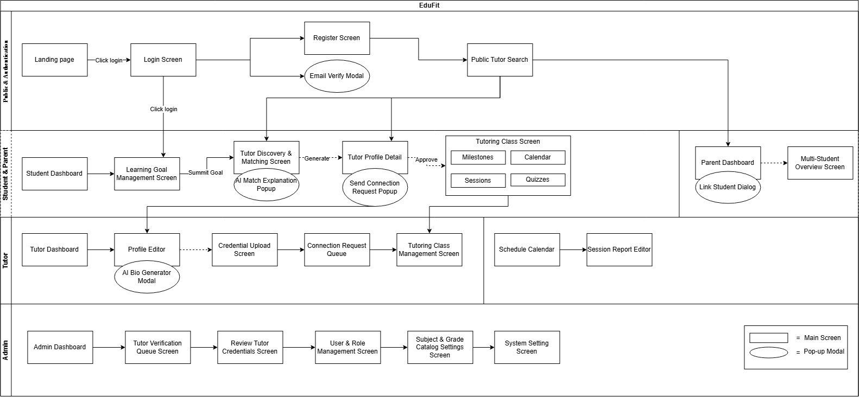

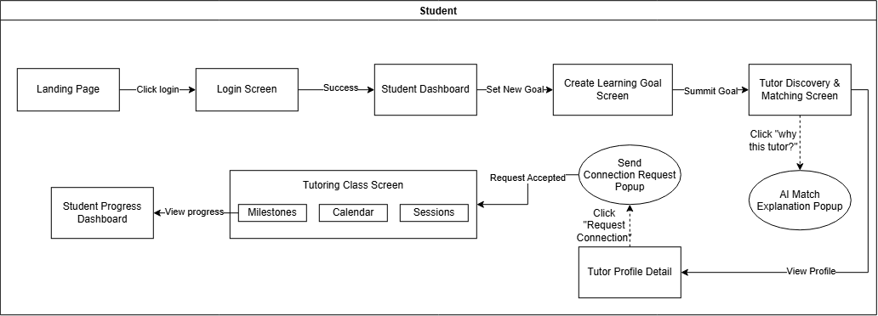

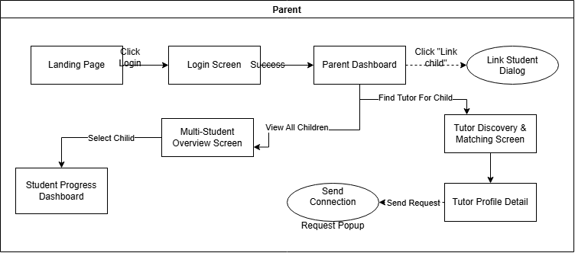

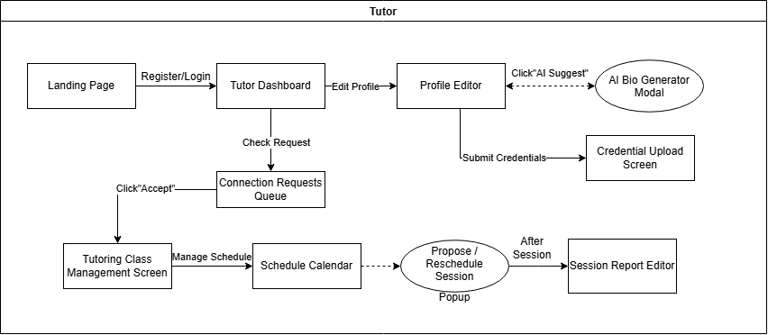

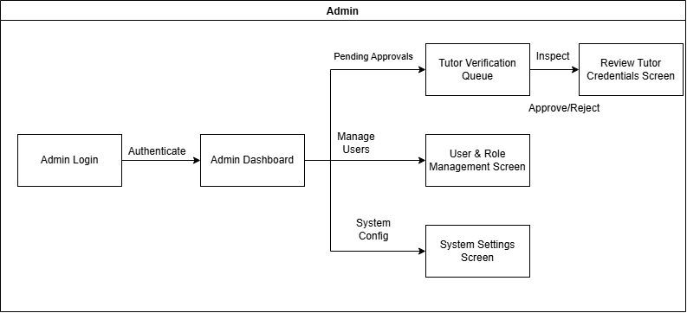

3.2 Screen Descriptions

# | Feature | Screen | Description
1 | Public & Auth | Landing Page | System introduction page, displaying core values (Verified tutors, Transparent matching, Data-driven progress), login/register navigation buttons, and a quick search bar.
2 | Public & Auth | Login Screen | Authenticate user accounts via Email/Password (or Zalo OAuth), directing users to the corresponding Dashboard based on their Role.
3 | Public & Auth | Register Screen | Allow guests to register an account with a role selection (Student, Parent, Tutor).
4 | Public & Auth | Email Verify Modal (Popup) | The dialog box requests the input of an OTP/email verification code to activate the account after successful registration.
5 | Discovery | Public Tutor Search | Allows guests or users to search and filter the approved list of tutors by subject, grade, price, and area.
6 | Discovery | Tutor Profile Detail | Display detailed tutor profiles: biography, teaching methods, subjects/grades, tuition fees, availability, approved qualifications, and reviews from other students.
7 | Goal & Matching | Student Dashboard | Student's main screen: summary of upcoming classes, current goals, and shortcut to create new goals.
8 | Goal & Matching | Create Learning Goal Screen | A screen for students to set structured learning goals (Subject, Grades 6–9, Score/Exam Preparation Goals, Free Schedule, Online/Offline Format, Budget).
9 | Goal & Matching | Tutor Discovery & Matching Screen | The list of tutors is automatically scored (MatchingScore) and ranked according to the learning objectives.
10 | Goal & Matching | AI Match Explanation Popup (Popup) | The dialog explains in natural language from AI why the recommended tutor is suitable for the student's goals.
11 | Connection | Send Connection Request Popup (Popup) | The dialog box allows students or parents to send study requests to tutors along with their learning goals and desired schedule.
12 | Class & Progress | Tutoring Class Screen (Student) | The student side classroom screen includes 3 tabs: Milestones (learning path), Calendar (class schedule), and Sessions (list of classes/reports).
13 | Class & Progress | Student Progress Dashboard | Study progress analysis table: goal/milestone completion rate, number of sessions attended, and overall progress review from the tutor.
14 | Parent Portal | Parent Dashboard | Parent dashboard, displaying a summary of academic performance and linking children's accounts.
15 | Parent Portal | Link Student Dialog (Popup) | Dialog box to enter/create a code to link the Parent account with the Student profile.
16 | Parent Portal | Multi-Student Overview Screen | The summary screen is specifically designed for parents with multiple children enrolled, allowing them to compare the overall progress and schedules of their children.
17 | Tutor Workspace | Tutor Dashboard | Tutor's dashboard: weekly teaching schedule statistics, new connection requests, list of classes being managed.
18 | Tutor Workspace | Profile Editor | The tutor's screen updates personal information, subjects taught, pricing, availability schedule, and teaching methods.
19 | Tutor Workspace | AI Bio Generator Modal (Popup) | The dialog box allows tutors to input raw data for the AI to generate a professional bio draft before saving.
20 | Tutor Workspace | Credential Upload Screen | Where tutors upload diplomas, certificates, and ID cards to send account verification requests to the Administrator.
21 | Tutor Workspace | Connection Requests Queue | List of connection requests from students/parents; tutors can Accept (create a class) or Decline.
22 | Tutor Workspace | Tutoring Class Management Screen | Tutor's classroom management screen: create a Learning Plan, break down goals into milestones.
23 | Tutor Workspace | Schedule Calendar | Teaching schedule in the form of a timetable/calendar; allows tutors to propose lessons, reschedule, or confirm make-up classes.
24 | Tutor Workspace | Session Report Editor | Screen recording after the class: attendance, lesson content, homework, assessment of understanding, and milestone updates.
25 | Admin Portal | Admin Dashboard | Administrator overview screen: number of users, number of tutors pending approval, statistics of active classes.
26 | Admin Portal | Tutor Verification Queue | The queue of tutor applications that have just registered is waiting for account approval.
27 | Admin Portal | Review Tutor Credentials Screen | The screen checks the details of the documents/degrees uploaded by the tutor, with an Approve (Verified) or Reject button along with a reason.
28 | Admin Portal | User & Role Management Screen | Manage the system-wide account list, lock/unlock violating accounts, support dispute link cancelation.
29 | Admin Portal | System Settings Screen | Configure the subject categories (Math, English,...), grade levels (6, 7, 8, 9), and algorithm parameters.

2.3 Screen Authorization

Screen | Guest | Student | Parent | Tutor | Admin | Detailed authority
Landing Page | x | x | x | x | x | View publicly
Login / Register / Verify | x |  |  |  |  | Only users who are not logged in
Public Tutor Search / Detail | x | x | x |  |  | View public tutor profile information
Student Dashboard |  | x |  |  |  | View and manage personal schedule/goals
Create Learning Goal Screen |  | x |  |  |  | Students create and edit learning goals.
Tutor Discovery & Matching |  | x | x |  |  | Find and receive tutor pairing suggestions.
AI Match Explanation Popup |  | x | x |  |  | Request AI to analyze the reason for the joint.
Send Connection Request |  | x | x |  |  | Send a request to open a teaching class.
Tutoring Class Screen |  | x | x |  |  | Students/Parents view the class progress.
Student Progress Dashboard |  | x | x | x |  | View the analysis of academic progress
Parent Dashboard |  |  | x |  |  | Parents manage the list of children.
Link Student Dialog |  | x | x |  |  | Create/enter the sub-account linking code
Multi-Student Overview Screen |  |  | x |  |  | Compare the learning data of multiple children
Tutor Dashboard |  |  |  |  | x | View teaching schedule and personal statistics
Profile Editor & AI Bio |  |  |  |  | x | Update bio, call AI for bio suggestions
Credential Upload Screen |  |  |  |  | x | Submit documents/degrees for approval
Connection Requests Queue |  |  |  |  | x | Accept or reject new students
Tutoring Class Management |  |  |  |  | x | Create/edit Learning Plan, allocate milestones
Schedule Calendar |  | x | x | x | x | Tutor schedules; Student/Parent confirms or reschedules
Session Report Editor |  | x(read) | x(read) | x(CRUD) |  | Tutor writes a report; Student/Parent reads & responds
Admin Dashboard |  |  |  |  | x | View the overall data of the entire platform.
Tutor Verification Queue |  |  |  |  | x | Review the tutor verification waiting list
Review Credentials Screen |  |  |  |  | x | Approve or reject the application with reasons.
User & Role Management |  |  |  |  | x | Lock/unlock account, intervene in links
System Settings Screen |  |  |  |  | x | Manage the course catalog, grade level

3. System High Level Design

3.1 Database Design

a. Database Schema

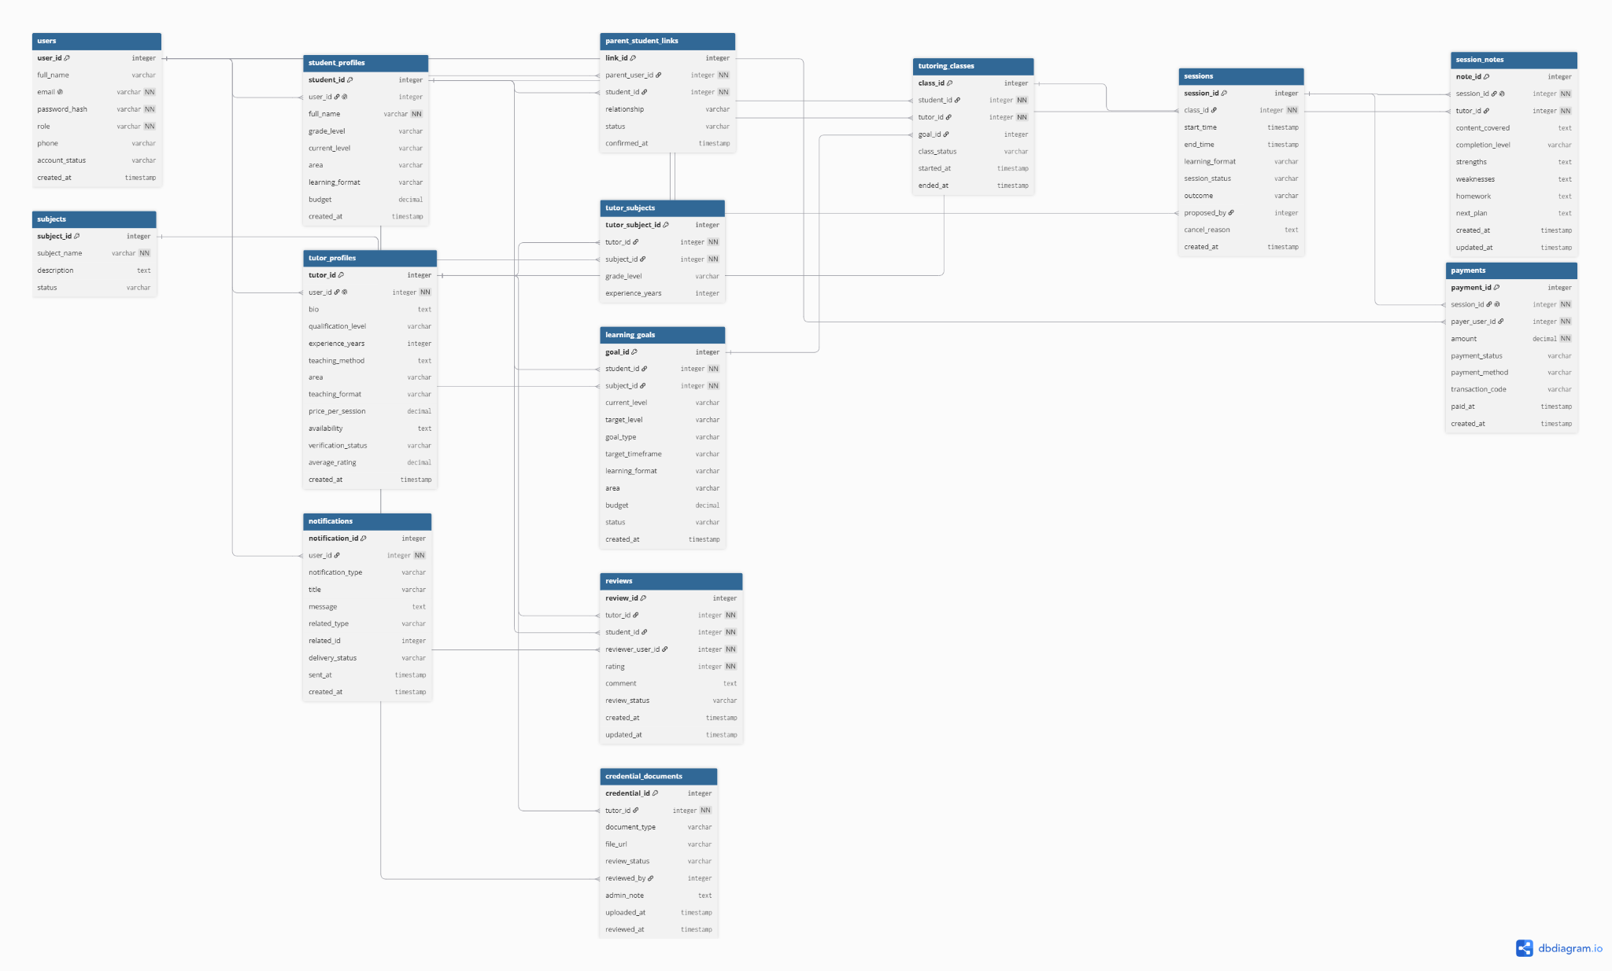

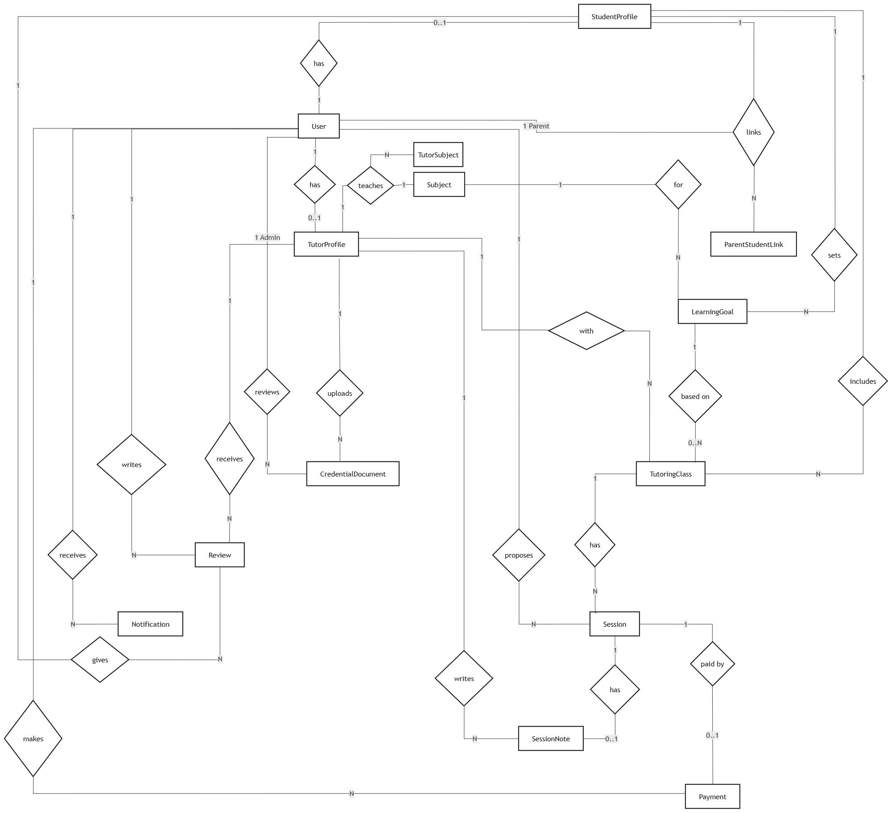

b. Table Descriptions
No | Table | Description
01 | User | Stores login accounts for all system users, including Student, Parent, Tutor, and Admin.  - Primary keys: user_id  - Foreign keys: none
02 | StudentProfile | Stores student learning information such as grade level, current level, area, learning format, and budget. A student may or may not have a separate login account.  - Primary keys: student_id  - Foreign keys: user_id references User(user_id)
03 | ParentStudentLink | Stores the relationship between a Parent account and a StudentProfile, allowing a parent to manage or view a student’s learning progress.  - Primary keys: link_id  - Foreign keys: parent_user_id references User(user_id), student_id references StudentProfile(student_id)
04 | TutorProfile | Stores tutor profile information such as biography, qualification, experience, teaching method, area, price, availability, and verification status.  - Primary keys: tutor_id  - Foreign keys: user_id references User(user_id)
05 | Subject | Stores the list of subjects supported by the platform, such as Math, English, or Physics.  - Primary keys: subject_id  - Foreign keys: none
06 | TutorSubject | Stores the many-to-many relationship between tutors and subjects, because one tutor can teach many subjects and one subject can be taught by many tutors.  - Primary keys: tutor_subject_id  - Foreign keys: tutor_id references TutorProfile(tutor_id), subject_id references Subject(subject_id)
07 | LearningGoal | Stores the student’s learning goals, including subject, current level, target level, timeframe, learning format, area, budget, and status. Matching is calculated dynamically from this table and tutor data.  - Primary keys: goal_id  - Foreign keys: student_id references StudentProfile(student_id), subject_id references Subject(subject_id)
08 | CredentialDocument | Stores credential documents uploaded by tutors for admin verification, such as certificates or degrees.  - Primary keys: credential_id  - Foreign keys: tutor_id references TutorProfile(tutor_id), reviewed_by references User(user_id)
09 | TutoringClass | Stores an active or historical tutoring relationship between one student and one tutor, usually based on a learning goal.  - Primary keys: class_id  - Foreign keys: student_id references StudentProfile(student_id), tutor_id references TutorProfile(tutor_id), goal_id references LearningGoal(goal_id)
10 | Session | Stores each tutoring session, including time, format, status, outcome, proposer, confirmer, and cancellation reason.  - Primary keys: session_id  - Foreign keys: class_id references TutoringClass(class_id), proposed_by references User(user_id), confirmed_by references User(user_id)
11 | SessionNote | Stores structured tutor notes after a session, including content covered, completion level, strengths, weaknesses, homework, and next plan. This data supports the progress dashboard.  - Primary keys: note_id  - Foreign keys: session_id references Session(session_id), tutor_id references TutorProfile(tutor_id)
12 | Review | Stores ratings and comments submitted by Student or Parent after at least one completed session with the tutor.  - Primary keys: review_id  - Foreign keys: tutor_id references TutorProfile(tutor_id), student_id references StudentProfile(student_id), reviewer_user_id references User(user_id)
13 | Payment | Stores simulated per-session payment records, including amount, status, payment method, transaction code, and payment time.  - Primary keys: payment_id  - Foreign keys: session_id references Session(session_id), payer_user_id references User(user_id)
14 | Notification | Stores notifications sent to users, such as verification results, booking updates, schedule changes, and payment receipts.  - Primary keys: notification_id  - Foreign keys: user_id references User(user_id)

3.2 Code Packages
[Provide the package diagram for each sub-system. The content of this section including the overall package diagram, the explanation, package and class naming conventions in each package. Please see the sample & description table format below]
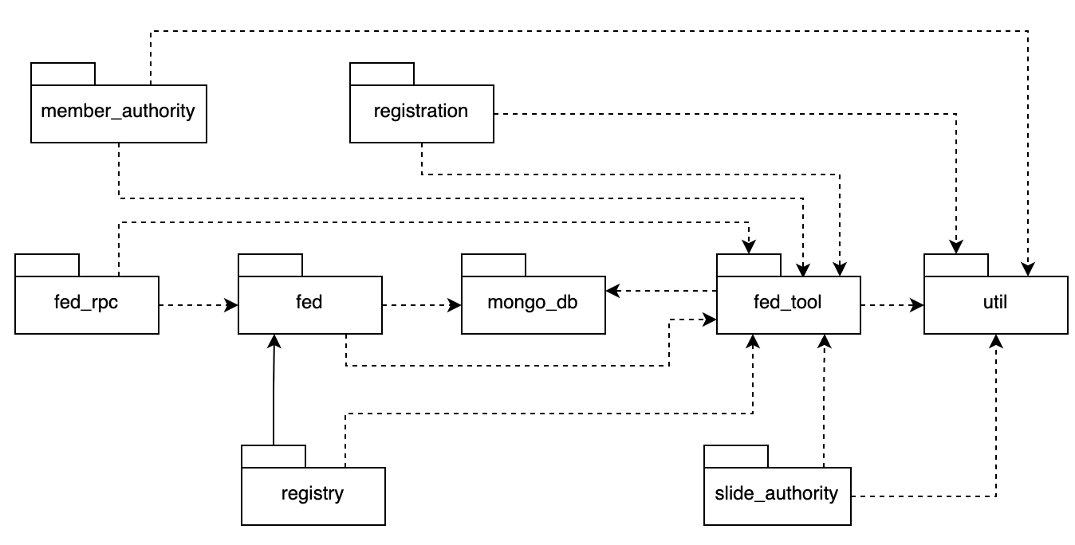
Package descriptions
No | Package | Description
01 | Member_authority | <Description of the package>
02 | registration | <Description of the package>
03 | …

II. Requirement Specifications

1. Account, Profile & Verification Function

Description

Group 1a — Authentication (UC1.1 – UC1.4)
Shared by all roles through the generalized actor User.

UC1.1 Register Account
UC ID and Name: | UC1.1 Register Account
Created By: | Hieu | Date Created: | 20-Sep-2026
Primary Actor: | User (Student, Parent or Tutor) | Secondary Actors: | None
Trigger: | A visitor selects "Sign up" on the landing page.
Description: | A visitor creates a new account by choosing a role and supplying basic credentials. The account becomes usable only after the visitor verifies ownership of the email address (email verification is a step of this use case, not a separate one).
Preconditions: | PRE-1: The visitor is not logged in.  PRE-2: The visitor has access to a valid email inbox.
Postconditions: | POST-1: A new account with the selected role exists and has status ACTIVE (after successful verification).  POST-2: The password is stored only as a salted hash.  POST-3: The verification token is invalidated after use.  POST-4: The visitor is directed to the Login page.
Normal Flow: | 1.1.0 Register with email verification  1. Visitor opens the sign-up page.  2. System displays the registration form: role (Student / Parent / Tutor), full name, email, password, confirm password.  3. Visitor selects a role, fills in the form and submits.  4. System validates the input format, email uniqueness and password policy (BR-01, BR-02).  5. System creates the account with status PENDING_VERIFICATION and stores the password hash.  6. System sends a verification email containing a single-use link that expires in 24 hours (BR-03).  7. System displays a "Check your email" message.  8. Visitor opens the verification link.  9. System validates the token and changes the account status to ACTIVE.  10. System displays a success message and a link to the Login page.
Alternative Flows: | 1.1.1 Resend verification email (branches at step 7, rejoins at step 8)  a. Visitor selects "Resend verification email".  b. System invalidates the previous token, sends a new one (limited to 1 request per minute) and shows a confirmation.
Exceptions: | 1.1.0.E1 Email already registered (step 4): System rejects the submission, shows a message and offers links to Login and Forgot Password.  1.1.0.E2 Invalid input (step 4): System shows field-level error messages and keeps the entered values (except the password fields).  1.1.0.E3 Email delivery fails (step 6): The account stays PENDING_VERIFICATION; System informs the visitor and offers "Resend verification email" (1.1.1).  1.1.0.E4 Verification token expired, invalid or already used (step 9): System shows an error and offers to send a new link (1.1.1).
Priority: | High (Must Have)
Frequency of Use: | Once per user account; higher volume expected during the launch and demo period.
Business Rules: | BR-01, BR-02, BR-03, BR-04, BR-05
Other Information: | Non-functional requirements (details in Appendix)  NFR-01 — Password storage (Security)  NFR-02 — Transport security (Security)  NFR-03 — One-time tokens (Security)  NFR-05 — Abuse protection (Security)  Related functional requirements (details in Appendix)  FR-03 — Account emails  Notes  If a failure occurs after the account is created but before the verification email is sent, the account stays PENDING_VERIFICATION (a known state) and the visitor can resend the email; no partial data is left in an undetermined state.
Assumptions: | Email sending is an internal module (no external Notification Service, see System Context Diagram).  Admin accounts are provisioned by the development team, not self-registered (BR-05); the model lists Admin under User only for the shared behaviors.  A tutor's real-world identity and credentials are checked later through UC1.10, not at registration.

UC1.2 Login
UC ID and Name: | UC1.2 Login
Created By: | Hieu | Date Created: | 20-Sep-2026
Primary Actor: | User (Student, Parent, Tutor, Admin) | Secondary Actors: | None
Trigger: | A user selects "Log in", or requests a protected page without an active session.
Description: | A registered user authenticates with email and password and is taken to the landing page appropriate to his/her role.
Preconditions: | PRE-1: The user has an account with status ACTIVE (email verified).  PRE-2: The user is not currently logged in on this device.
Postconditions: | POST-1: An authenticated session bound to the user's role is created.  POST-2: The failed-attempt counter of the account is reset to 0.  POST-3: The last-login time is recorded.  POST-4: The user is redirected to the role-specific Dashboard, or to profile creation if no profile exists yet.
Normal Flow: | 1.2.0 Login with email and password  1. User opens the Login page.  2. System displays the email and password form.  3. User enters the credentials and submits.  4. System verifies the credentials against the stored hash (NFR-01).  5. System checks that the account status is ACTIVE (BR-06).  6. System creates the session (NFR-04) and resets the failed-attempt counter.  7. System redirects the user: Admin, Tutor, Student and Parent to their Dashboard; a Tutor without a profile to UC1.5, a Student without a profile to UC1.8.
Alternative Flows: | 1.2.1 Return to the originally requested page (after step 6)  a. If the user was redirected to Login from a protected URL, System redirects to that URL instead of the default Dashboard (only if the URL is permitted for the user's role).  1.2.2 Forgot password (branches at step 2)  a. User selects "Forgot password"; System starts UC1.4 Manage Password.
Exceptions: | 1.2.0.E1 Invalid credentials (step 4): System shows a generic message "Email or password is incorrect" and increments the failed-attempt counter (NFR-05).  1.2.0.E2 Account temporarily locked (step 4): System refuses the attempt and shows the remaining lock time (NFR-05).  1.2.0.E3 Email not verified (step 5): System explains that verification is required and offers "Resend verification email" (UC1.1, flow 1.1.1).  1.2.0.E4 Account deactivated by Admin (step 5): System denies access and shows a message to contact support (BR-06).
Priority: | High (Must Have)
Frequency of Use: | Several times per user per week; peak concurrency during class hours and evenings.
Business Rules: | BR-06
Other Information: | Non-functional requirements (details in Appendix)  NFR-01 — Password storage (Security)  NFR-02 — Transport security (Security)  NFR-04 — Session management (Security)  NFR-05 — Abuse protection (Security)  NFR-06 — No account enumeration (Security)  NFR-07 — Server-side authorization (Security)
Assumptions: | Users log in with email and password only (no social login in this version).  A user may hold sessions on several devices at the same time.

UC1.3 Logout
UC ID and Name: | UC1.3 Logout
Created By: | Hieu | Date Created: | 20-Sep-2026
Primary Actor: | User (Student, Parent, Tutor, Admin) | Secondary Actors: | None
Trigger: | A logged-in user selects "Log out".
Description: | A user ends the current session so that the account cannot be used from this device.
Preconditions: | PRE-1: The user is logged in.
Postconditions: | POST-1: The current session is invalidated on the server.  POST-2: Authentication data is cleared from the client.  POST-3: The user is on the Login (or landing) page.
Normal Flow: | 1.3.0 Logout from the current device  1. User selects "Log out".  2. System invalidates the current session.  3. System clears the client-side session data.  4. System redirects to the Login page with a "You have been logged out" message.
Alternative Flows: | 1.3.1 Session already expired (step 1)  a. System detects that the session is no longer valid, skips step 2 and redirects to the Login page.
Exceptions: | 1.3.0.E1 Network or server failure (step 2): The client still clears its local session data and redirects; the server-side session ends when it expires naturally (NFR-04).
Priority: | Medium (Must Have)
Frequency of Use: | About once per login session.
Business Rules: | None.
Other Information: | Non-functional requirements (details in Appendix)  NFR-04 — Session management (Security)  Notes  Logging out on one device does not affect the sessions on other devices.
Assumptions: | Sessions are token-based and can be invalidated server-side.

UC1.4 Manage Password
UC ID and Name: | UC1.4 Manage Password
Created By: | Hieu | Date Created: | 20-Sep-2026
Primary Actor: | User (Student, Parent, Tutor, Admin) | Secondary Actors: | None
Trigger: | A user selects "Forgot password" on the Login page, or "Change password" in account settings.
Description: | A user regains or updates control of the account by resetting a forgotten password (not logged in) or changing the current one (logged in). The two cases share one goal and differ only in precondition, so they are flows of one use case.
Preconditions: | PRE-1 (forgot/reset flow): The account exists and has a registered email address; the user is not logged in.  PRE-2 (change flow, 1.4.1): The user is logged in.
Postconditions: | POST-1: The password hash is replaced with the hash of the new password.  POST-2: The reset token (if any) is invalidated.  POST-3: All other active sessions of the account are invalidated.  POST-4: A confirmation email about the password change is sent to the user.
Normal Flow: | 1.4.0 Forgot and reset password  1. User selects "Forgot password".  2. System asks for the account email.  3. User enters the email and submits.  4. System always shows the same message ("If the account exists, a reset link has been sent"); if the account exists, it sends a single-use reset link that expires in 30 minutes (NFR-03).  5. User opens the reset link.  6. System validates the token and displays the new-password form.  7. User enters and confirms the new password.  8. System validates the password policy (BR-02), stores the new hash, invalidates the token and all other sessions.  9. System sends a confirmation email, displays a success message and redirects to the Login page.
Alternative Flows: | 1.4.1 Change password while logged in (replaces steps 1-9)  a. User opens Account Settings and selects "Change password".  b. System displays a form: current password, new password, confirm new password.  c. User fills in and submits.  d. System verifies the current password, validates the new password (BR-02) and checks that it differs from the current one.  e. System stores the new hash, invalidates all other sessions (the current one stays active) and sends a confirmation email.  f. System displays a success message.
Exceptions: | 1.4.0.E1 Reset token expired, invalid or already used (step 6): System shows an error and offers to request a new link.  1.4.0.E2 New password violates the policy or the two entries do not match (step 8): System shows the errors; the token remains valid until it expires.  1.4.0.E3 Too many reset requests (step 3): System refuses further requests for a cooling-off period (NFR-05) while still showing the neutral message.  1.4.1.E1 Current password is incorrect (step d): System rejects the change; the attempt counts toward the lockout limit (NFR-05).  1.4.1.E2 New password equals the current password (step d): System asks for a different password.
Priority: | Medium (Should Have)
Frequency of Use: | Occasional; a small share of users per month.
Business Rules: | BR-02
Other Information: | Non-functional requirements (details in Appendix)  NFR-01 — Password storage (Security)  NFR-03 — One-time tokens (Security)  NFR-04 — Session management (Security)  NFR-05 — Abuse protection (Security)  NFR-06 — No account enumeration (Security)  NFR-11 — Atomic saves (Reliability)  Related functional requirements (details in Appendix)  FR-03 — Account emails  FR-04 — Session invalidation after password change
Assumptions: | The email service is available; there is no SMS or security-question recovery.  If needed, forgot / reset / change can be split into separate use cases later without changing Group 1a.

Group 1b — Profile Management (UC1.5 – UC1.9)
UC1.7 is an optional extension of UC1.5 and UC1.6.

UC1.5 Create Tutor Profile
UC ID and Name: | UC1.5 Create Tutor Profile
Created By: | Hieu | Date Created: | 20-Sep-2026
Primary Actor: | Tutor | Secondary Actors: | None (the AI Provider participates only in the extension UC1.7)
Trigger: | A Tutor with no profile logs in for the first time, or selects "Create profile".
Description: | A Tutor enters the structured information that Search and Matching rely on: subjects, levels, teaching mode, area, availability, price and a bio. The bio may optionally be drafted with AI (extension point after the bio field).
Preconditions: | PRE-1: The user is logged in as a Tutor.  PRE-2: The Tutor does not yet have a profile.
Postconditions: | POST-1: The Tutor profile is saved with status UNVERIFIED (or DRAFT if saved incomplete).  POST-2: The profile is not visible in Search or Matching until verified (BR-08).  POST-3: The Tutor is prompted to submit a verification request (UC1.10).
Normal Flow: | 1.5.0 Create a complete tutor profile  1. Tutor opens the "Create profile" page.  2. System displays the form: display name, headline, bio, subjects and the levels taught for each subject, teaching mode (online / offline / both), teaching area (required if offline), weekly availability slots, price per session, years of experience and teaching method.  3. Tutor fills in the form. [Extension point: Generate AI-Suggested Bio (UC1.7) may be invoked at the bio field.]  4. Tutor submits the form.  5. System validates the required fields and formats (BR-07).  6. System saves the profile with status UNVERIFIED.  7. System displays a success message and a call to action "Get verified" (UC1.10).
Alternative Flows: | 1.5.1 Save as draft (branches at step 4)  a. Tutor selects "Save draft".  b. System saves the entered data without enforcing required fields and sets status DRAFT; the Tutor can resume later. A DRAFT profile cannot be submitted for verification.  1.5.2 Use AI bio suggestion (branches at step 3)  a. Tutor invokes UC1.7; if the Tutor accepts a draft, the bio field is filled and the flow resumes at step 3.
Exceptions: | 1.5.0.E1 Required field missing or invalid (step 5): System highlights the fields and keeps the entered data.  1.5.0.E2 Invalid availability, e.g. end time before start time or overlapping slots (step 5): System rejects the slot and explains why.  1.5.0.E3 System error while saving (step 6): Nothing is saved; entered data stays in the form and the Tutor may retry.  1.5.0.E4 Session expired (step 4): System redirects to Login; unsaved input is not recovered.
Priority: | High (Must Have)
Frequency of Use: | Once per Tutor.
Business Rules: | BR-07, BR-08
Other Information: | Notes  Subjects, levels, area, availability and price are stored as structured data (not free text) because Group 2 filters and ranks on them and UC4.2 checks conflicts against the availability.  Availability is stored as recurring weekly slots.
Assumptions: | Subjects are chosen from a catalog that Admin can extend, so any subject and level is supported.  Price is expressed per session in VND.

UC1.6 Edit Tutor Profile
UC ID and Name: | UC1.6 Edit Tutor Profile
Created By: | Hieu | Date Created: | 20-Sep-2026
Primary Actor: | Tutor | Secondary Actors: | None (the AI Provider participates only in the extension UC1.7)
Trigger: | A Tutor selects "Edit profile".
Description: | A Tutor updates an existing profile (teaching information, availability, price, bio). The bio may again be drafted with AI.
Preconditions: | PRE-1: The user is logged in as a Tutor.  PRE-2: The Tutor has an existing profile.
Postconditions: | POST-1: The updated profile is saved and the last-modified time is recorded.  POST-2: The verification status is unchanged, except as stated in BR-08.  POST-3: Already scheduled sessions are not affected by the change.
Normal Flow: | 1.6.0 Update tutor profile  1. Tutor opens "Edit profile".  2. System displays the form pre-filled with the current data.  3. Tutor modifies the fields. [Extension point: Generate AI-Suggested Bio (UC1.7) at the bio field.]  4. Tutor submits the changes.  5. System validates the input (BR-07).  6. System saves the changes and records the modification time.  7. System displays the updated profile with a success message.
Alternative Flows: | 1.6.1 Cancel editing (branches at step 3 or 4)  a. Tutor selects "Cancel"; if there are unsaved changes, System asks for confirmation, then discards them and returns to the profile view.  1.6.2 Use AI bio suggestion (branches at step 3)  a. Tutor invokes UC1.7; the flow resumes at step 3 after the Tutor accepts or rejects the draft.
Exceptions: | 1.6.0.E1 Required field missing or invalid (step 5): System highlights the fields and keeps the entered data.  1.6.0.E2 Edit conflict: the profile was changed in another session after this form was loaded (step 6): System warns, shows the latest version and asks the Tutor to reload before re-applying the changes.  1.6.0.E3 System error while saving (step 6): Nothing is saved; entered data stays in the form.
Priority: | High (Must Have)
Frequency of Use: | A few times per Tutor per month.
Business Rules: | BR-07, BR-08
Other Information: | Notes  Changes to availability affect future matching results only; sessions already agreed in Group 4 remain valid.  Credential documents are not edited here; they are handled in UC1.10 / UC1.11.
Assumptions: | Optimistic locking (version or timestamp) is used to detect edit conflicts.

UC1.7 Generate AI-Suggested Bio
UC ID and Name: | UC1.7 Generate AI-Suggested Bio
Created By: | Hieu | Date Created: | 20-Sep-2026
Primary Actor: | Tutor | Secondary Actors: | AI Provider (LLM API)
Trigger: | A Tutor selects "Suggest bio with AI" while creating or editing a profile (extends UC1.5 and UC1.6).
Description: | System sends the Tutor's professional information to the AI Provider and shows a draft bio. The draft is only a suggestion: the Tutor reviews, edits and explicitly accepts it before it enters the profile.
Preconditions: | PRE-1: The Tutor is on the Create or Edit Tutor Profile form (UC1.5 / UC1.6).  PRE-2: The Tutor has entered at least subjects, levels and a short summary of experience.  PRE-3: The AI feature is enabled and the Tutor has not exceeded the regeneration limit (BR-10).
Postconditions: | POST-1: If accepted, the bio field of the form contains the draft (still unsaved until the Tutor saves via UC1.5 / UC1.6).  POST-2: If rejected or on failure, the bio field is unchanged.  POST-3: The AI request is logged with time, Tutor id, result status and latency, without the message content, so Admin can monitor AI errors.
Normal Flow: | 1.7.0 Generate and accept a draft bio  1. Tutor selects "Suggest bio with AI".  2. System checks that the minimum information is present.  3. System builds the request from professional information only (NFR-09).  4. System sends the request to the AI Provider.  5. AI Provider returns a draft bio.  6. System checks the output (not empty, within length limit) and displays it labelled "AI-generated draft" next to the current bio.  7. Tutor reviews and optionally edits the draft.  8. Tutor selects "Use this bio".  9. System inserts the text into the bio field and returns to the profile form.
Alternative Flows: | 1.7.1 Regenerate (branches at step 7, returns to step 3)  a. Tutor selects "Generate another version"; System repeats from step 3 while the limit in BR-10 is not exceeded.  1.7.2 Reject draft (branches at step 8)  a. Tutor selects "Discard"; System closes the draft, leaves the bio unchanged and returns to the form.
Exceptions: | 1.7.0.E1 Insufficient information (step 2): System lists the missing fields and does not call the AI Provider.  1.7.0.E2 AI Provider timeout, error or unavailable (steps 4-5): After 15 seconds or on an error response, System shows "AI is unavailable, please write your bio manually"; the form is untouched and the failure is logged (NFR-10, FR-05).  1.7.0.E3 Output fails validation, e.g. empty or too long (step 6): Treated like E2; the Tutor may retry.  1.7.0.E4 Regeneration limit reached (step 7): System disables regeneration and suggests editing the current draft manually.
Priority: | Medium (Should Have)
Frequency of Use: | A few times per Tutor while completing the profile; low overall.
Business Rules: | BR-09, BR-10
Other Information: | Non-functional requirements (details in Appendix)  NFR-09 — Data minimisation towards the AI Provider (Privacy)  NFR-10 — AI failure isolation (Reliability)  Related functional requirements (details in Appendix)  FR-05 — AI request logging  FR-06 — Non-AI fallback  Notes  The prompt instructs the model to use only the supplied facts and not to add credentials, employers or achievements. Automatic detection of invented claims is not guaranteed, so the Tutor's review (BR-09) and the Admin verification (UC1.12) are the real controls.  Nothing is persisted by this use case; on any failure the profile form is unaffected.
Assumptions: | The LLM API is an external service reachable over HTTPS.  Bio language follows the language used by the Tutor in the form.

UC1.8 Create Student Profile
UC ID and Name: | UC1.8 Create Student Profile
Created By: | Hieu | Date Created: | 20-Sep-2026
Primary Actor: | Student | Secondary Actors: | None
Trigger: | A Student without a profile logs in for the first time (onboarding), or selects "Complete profile".
Description: | A Student enters basic information and one or more structured learning goals. Matching (UC2.3) pre-fills its criteria from this data.
Preconditions: | PRE-1: The user is logged in as a Student.  PRE-2: The Student does not yet have a profile.
Postconditions: | POST-1: The Student profile and at least one learning goal are saved (unless flow 1.8.1 is used).  POST-2: A "profile complete" indicator is set so that Matching can check its required data.  POST-3: The Student is taken to the Dashboard.
Normal Flow: | 1.8.0 Create profile and learning goals  1. System displays the onboarding page after the first login.  2. Student enters basic information: full name and education level or grade.  3. System displays the goal form: subject, current level, desired level, goal type (consolidate, improve grades, advanced study, exam preparation, other), deadline, learning mode (online / offline / both), area (if offline), availability slots and budget range.  4. Student fills in at least one goal.  5. Student submits.  6. System validates the data (BR-11, BR-12).  7. System saves the profile and goals in one transaction and marks the profile complete.  8. System displays the Dashboard with a suggestion to run "Get Matched Tutors".
Alternative Flows: | 1.8.1 Skip onboarding (branches at steps 2-4)  a. Student selects "Do it later".  b. System saves the account as incomplete and opens the Dashboard; Get Matched Tutors stays blocked until the data required by BR-11 is provided.  1.8.2 Add another goal (branches at step 4)  a. Student selects "Add another goal"; System shows an empty goal form and the flow repeats from step 3 for the next subject.
Exceptions: | 1.8.0.E1 Required field missing or invalid (step 6): System highlights the fields and keeps the entered data.  1.8.0.E2 Deadline in the past, or desired level not above the current level (step 6): System explains the constraint (BR-12).  1.8.0.E3 System error while saving (step 7): The transaction is rolled back, nothing is saved and the Student may retry.
Priority: | High (Must Have)
Frequency of Use: | Once per Student; goals may be added later through UC1.9.
Business Rules: | BR-11, BR-12, BR-17
Other Information: | Non-functional requirements (details in Appendix)  NFR-11 — Atomic saves (Reliability)  Notes  Goals are structured data because Matching and later the progress views depend on them.  Only the minimum personal data is collected (no home address; area is coarse-grained).
Assumptions: | Education level is chosen from a list (school grades, university, other), so any level is supported.  A Parent is linked later through UC3.1; parent contact information is not part of the Student profile.

UC1.9 Edit Student Profile
UC ID and Name: | UC1.9 Edit Student Profile
Created By: | Hieu | Date Created: | 20-Sep-2026
Primary Actor: | Student | Secondary Actors: | None
Trigger: | A Student selects "Edit profile" or "Edit goals".
Description: | A Student updates basic information and learning goals so that Matching and progress tracking reflect current needs. Only the Student can perform this use case; a linked Parent has read-only access elsewhere.
Preconditions: | PRE-1: The user is logged in as a Student.  PRE-2: The Student has an existing profile.
Postconditions: | POST-1: The updated profile and goals are saved.  POST-2: Linked Parents see the updated data in their read-only views.  POST-3: Earlier matching results are not recalculated automatically; the Student runs Get Matched Tutors again.
Normal Flow: | 1.9.0 Update profile and goals  1. Student opens "Edit profile".  2. System displays the current profile and goals in editable form.  3. Student changes basic information and/or goal fields.  4. Student submits.  5. System validates the data (BR-11, BR-12).  6. System saves the changes in one transaction.  7. System displays the updated profile with a success message.
Alternative Flows: | 1.9.1 Add a goal (branches at step 3)  a. Student selects "Add goal", fills in the goal form (as in UC1.8 step 3) and continues at step 4.  1.9.2 Remove a goal (branches at step 3)  a. Student selects "Remove" on a goal and confirms.  b. System deletes the goal, or archives it instead if it is referenced by a connection request or an engagement; continues at step 4.
Exceptions: | 1.9.0.E1 Required field missing or invalid, or last remaining goal removed while Matching data is required (step 5): System explains what is missing (BR-11, BR-12).  1.9.0.E2 Non-owner attempts the edit, e.g. a linked Parent (any step): System denies with an authorization error and changes nothing (BR-17).  1.9.0.E3 System error while saving (step 6): The transaction is rolled back; the previous data remains.
Priority: | High (Must Have)
Frequency of Use: | A few times per Student per term, typically when goals or availability change.
Business Rules: | BR-11, BR-12, BR-17
Other Information: | Non-functional requirements (details in Appendix)  NFR-07 — Server-side authorization (Security)  NFR-11 — Atomic saves (Reliability)  Notes  Archiving a referenced goal keeps historical references consistent for progress tracking.
Assumptions: | Editing a goal does not change engagements that already exist.

Group 1c — Tutor Verification (UC1.10 – UC1.12)
UC1.11 is included in UC1.10; UC1.12 is performed by Admin.

UC1.10 Submit Verification Request
UC ID and Name: | UC1.10 Submit Verification Request
Created By: | Hieu | Date Created: | 20-Sep-2026
Primary Actor: | Tutor | Secondary Actors: | None
Trigger: | A Tutor selects "Get verified" (from the profile page or the prompt after UC1.5).
Description: | A Tutor asks Admin to review his/her credentials. The request must include supporting proof, so Upload Proof of Credentials (UC1.11) is a mandatory included step.
Preconditions: | PRE-1: The user is logged in as a Tutor.  PRE-2: The Tutor profile is complete (status UNVERIFIED, not DRAFT).  PRE-3: The Tutor has no request with status PENDING (BR-14).
Postconditions: | POST-1: A verification request with status PENDING and its documents is stored.  POST-2: The profile status is PENDING_VERIFICATION.  POST-3: The request appears in the Admin review queue.  POST-4: An in-app notification confirming submission is recorded for the Tutor.
Normal Flow: | 1.10.0 Submit credentials for review  1. Tutor opens the "Get verified" page.  2. System displays the requirements and a credential form: credential type (degree, certificate, teaching licence, student card, other), issuing institution, year and an optional note.  3. Tutor enters the details of a credential.  4. Include UC1.11 Upload Proof of Credentials for that credential; the Tutor may add further credentials.  5. Tutor ticks the declaration that the documents are genuine and submits.  6. System checks that at least one credential has at least one proof file.  7. System creates the request with status PENDING, sets the profile to PENDING_VERIFICATION and locks the submitted documents against changes.  8. System adds the request to the Admin queue and records the notification (FR-01).  9. System displays a confirmation with the request status.
Alternative Flows: | 1.10.1 Resubmit after rejection (start of flow, continues at step 3)  a. System shows the Admin's rejection reason and pre-fills the previous credential data; the Tutor corrects it and continues at step 3 (BR-14).
Exceptions: | 1.10.0.E1 Profile incomplete (step 1): System blocks the request and links to Edit Tutor Profile (UC1.6).  1.10.0.E2 A PENDING request already exists (step 1): System shows its status and does not create another.  1.10.0.E3 No credential or no proof file provided (step 6): System refuses to submit and shows what is missing.  1.10.0.E4 System error while saving (step 7): The transaction is rolled back, the request is not created and orphaned uploaded files are removed by a scheduled clean-up.
Priority: | High (Must Have)
Frequency of Use: | Once per Tutor, plus occasional resubmissions.
Business Rules: | BR-08, BR-14, BR-16
Other Information: | Non-functional requirements (details in Appendix)  NFR-08 — Document storage (Security)  NFR-11 — Atomic saves (Reliability)  Related functional requirements (details in Appendix)  FR-01 — In-app notification of verification events  FR-11 — Clean-up of orphaned uploads  Notes  Verification is the platform's main trust mechanism and supports the transparency goal.
Assumptions: | Admin reviews manually; no review-time SLA is enforced by the system.  A Tutor may add credentials that were not required by any rule; the Admin decides whether they suffice.

UC1.11 Upload Proof of Credentials
UC ID and Name: | UC1.11 Upload Proof of Credentials
Created By: | Hieu | Date Created: | 20-Sep-2026
Primary Actor: | Tutor (through UC1.10) | Secondary Actors: | None
Trigger: | Invoked at step 4 of UC1.10 when the Tutor selects "Add proof". It is not started on its own.
Description: | A Tutor attaches one or more document files as evidence for a credential entered in the verification request.
Preconditions: | PRE-1: UC1.10 is in progress and a credential entry has been started.
Postconditions: | POST-1: Each accepted file is stored privately and linked to the credential entry, with file name, type, size and upload time recorded.  POST-2: Control returns to UC1.10.
Normal Flow: | 1.11.0 Upload proof files  1. Tutor selects "Add proof" on a credential.  2. System opens the file selection dialog (drag and drop is also accepted).  3. Tutor selects one or more files.  4. System validates file type, size and count (BR-13).  5. System uploads each file and displays a progress indicator.  6. System stores the files in private storage and lists them with a preview or file name.  7. Tutor adds more files or continues; control returns to UC1.10.
Alternative Flows: | 1.11.1 Remove an uploaded file (after step 6)  a. Tutor selects "Remove" on a file; System deletes it from storage and updates the list; the flow continues at step 3 or 7.
Exceptions: | 1.11.0.E1 Unsupported type or file too large (step 4): System rejects that file with a reason and keeps the others.  1.11.0.E2 Maximum number of files reached (step 4): System refuses additional files and shows the limit.  1.11.0.E3 Upload interrupted or network lost (step 5): The file is marked as failed, no partial file is kept and the Tutor can retry.  1.11.0.E4 Storage service unavailable (step 6): System shows an error and asks the Tutor to try again later; the credential entry is preserved.
Priority: | High (Must Have)
Frequency of Use: | 1-5 files per verification request.
Business Rules: | BR-13, BR-16
Other Information: | Non-functional requirements (details in Appendix)  NFR-08 — Document storage (Security)  Notes  Tutors are advised to cover unrelated sensitive numbers (e.g. ID numbers) in scans before uploading.
Assumptions: | Malware scanning is desirable but optional for the course scope.

UC1.12 Review Tutor Verification
UC ID and Name: | UC1.12 Review Tutor Verification
Created By: | Hieu | Date Created: | 20-Sep-2026
Primary Actor: | Admin | Secondary Actors: | None
Trigger: | An Admin opens the verification queue or selects a PENDING request.
Description: | An Admin examines the credentials and proof submitted by a Tutor and either approves (the profile becomes verified) or rejects the request with a reason. Both outcomes are flows of this one use case.
Preconditions: | PRE-1: The user is logged in as an Admin.  PRE-2: At least one verification request has status PENDING.
Postconditions: | POST-1 (approved): The request is APPROVED, the Tutor profile is marked verified and becomes eligible for Search and Matching.  POST-2 (rejected): The request is REJECTED with the recorded reason; the profile stays unverified and the Tutor may resubmit.  POST-3: The reviewer, time and decision are written to the audit log.  POST-4: A notification of the result is recorded for the Tutor.
Normal Flow: | 1.12.0 Approve a verification request  1. Admin opens the verification queue.  2. System lists PENDING requests, oldest first, with Tutor name and submission date.  3. Admin selects a request.  4. System displays the Tutor profile summary, credential details and a viewer for the proof files.  5. Admin compares the documents with the claims in the profile.  6. Admin selects "Approve".  7. System asks for confirmation.  8. Admin confirms.  9. System sets the request to APPROVED, marks the profile verified (badge), records reviewer and time, writes the audit log and records the notification (FR-01, FR-02).  10. System displays a confirmation and returns to the queue.
Alternative Flows: | 1.12.1 Reject request (branches at step 6, rejoins at step 10)  a. Admin selects "Reject" and enters a reason (BR-15), then confirms.  b. System sets the request to REJECTED, keeps the profile unverified, records the reason, writes the audit log and records the notification to the Tutor including the reason.  1.12.2 Filter the queue (branches at step 2)  a. Admin filters or searches by Tutor name, date or status; System updates the list and the flow continues at step 3.
Exceptions: | 1.12.0.E1 Request already handled by another Admin (step 8): System detects the changed status, informs the Admin and refreshes the queue without applying a second decision.  1.12.0.E2 Proof file cannot be opened or is corrupted (step 4): System flags the file; the Admin can reject with a reason such as "unreadable document".  1.12.1.E1 Rejection reason left empty (flow 1.12.1, step a): System blocks the rejection until a reason is entered.  1.12.0.E3 System error while saving the decision (step 9): The transaction is rolled back and the request remains PENDING.
Priority: | High (Must Have)
Frequency of Use: | Proportional to new tutor sign-ups; several per day at most for the expected user base.
Business Rules: | BR-08, BR-15, BR-16
Other Information: | Non-functional requirements (details in Appendix)  NFR-11 — Atomic saves (Reliability)  Related functional requirements (details in Appendix)  FR-01 — In-app notification of verification events  FR-02 — Audit log of Admin decisions  Notes  The verified badge means that documents were reviewed by Admin; it must not be presented as a guarantee of teaching quality.  Only one decision per request is possible; a rejected Tutor creates a new request through UC1.10 (flow 1.10.1).
Assumptions: | Revoking verified status after approval is not modelled in this version.  Admin is trusted to judge document authenticity manually; no external verification service is used.

Business Rules

ID | Business Rule | Business Rule Description
BR-01 | Unique email | An email address can be registered to at most one account.
BR-02 | Password complexity | A password has at least 8 characters, including at least one letter and one digit (proposed).
BR-03 | Email verification required | A new account cannot log in until its email address is verified. The verification link is valid for 24 hours (proposed).
BR-04 | One role per account | Each account has exactly one role (Student, Parent, Tutor or Admin), fixed at registration. A person who needs two roles uses two emails.
BR-05 | Admin provisioning | Admin accounts are created by the system operators and cannot be self-registered.
BR-06 | Account status | Only accounts with status ACTIVE can log in. Admin may deactivate an account.
BR-07 | Tutor profile required data | A Tutor profile is complete only if it has a display name, at least one subject with at least one level, a teaching mode, a price per session and at least one availability slot. The teaching area is required when the mode includes offline.
BR-08 | Verification and visibility | Only tutors with verified status appear in Search and Matching. Editing bio, price or availability keeps the verified status; changing the credential documents requires a new verification request.
BR-09 | AI output is a draft | AI-generated profile text is never saved automatically. The Tutor must review and explicitly accept it. The AI must not invent credentials, experience or achievements.
BR-10 | AI bio regeneration limit | A Tutor may request a new AI bio draft at most 5 times per editing session (proposed).
BR-11 | Student data required for Matching | To use Get Matched Tutors, the Student profile must contain the education level and at least one goal with subject, learning mode, availability and budget range (and area when the mode includes offline).
BR-12 | Learning goal validity | A goal deadline must be in the future, and the desired level must be higher than the current level. A goal referenced by a connection request or an engagement is archived, not deleted.
BR-13 | Proof file acceptance | Accepted proof files are PDF, JPG and PNG, at most 10 MB each and at most 5 files per credential (proposed).
BR-14 | One pending verification request | A Tutor can have only one PENDING verification request at a time. After a rejection the Tutor may submit a new request.
BR-15 | Rejection reason required | Rejecting a verification request requires a written reason, which is shown to the Tutor.
BR-16 | Credential document access | Credential documents can be viewed only by the owning Tutor and by Admin. They are never shown publicly.
BR-17 | Student data ownership | Only the Student can edit his/her profile and goals. A linked Parent has read-only access, and only while the link is CONFIRMED and active.

Related Functional Requirements (FR)

ID | Functional Requirement | Description
FR-01 | In-app notification of verification events | When a verification request is submitted, approved or rejected, the system records an in-app notification for the Tutor (including the rejection reason). It is displayed through View Notifications (UC6.3); there is no separate use case.
FR-02 | Audit log of Admin decisions | Each approve or reject decision is written to the audit log with reviewer, time, request and decision.
FR-03 | Account emails | The system sends the verification email, the password-reset email and the password-changed confirmation email.
FR-04 | Session invalidation after password change | After a password reset or change, all other active sessions of the account are invalidated.
FR-05 | AI request logging | Each AI call is logged with time, user, status and latency, without the content, so that Admin can monitor AI errors.
FR-06 | Non-AI fallback | When the AI is unavailable, the Tutor writes the bio manually (UC1.7) and the user sees the rule-based breakdown as plain text instead of the AI explanation (UC2.4).
FR-11 | Clean-up of orphaned uploads | A scheduled job removes uploaded files that are not attached to a submitted request.

Related Non-Functional Requirements (NFR)

ID | Category / Requirement | Description
NFR-01 | Security — Password storage | Passwords are stored only as salted hashes produced by a slow algorithm (bcrypt or Argon2); reversible or fast hashes such as MD5 are not allowed. Passwords are never written to logs.
NFR-02 | Security — Transport security | All traffic between client and server uses HTTPS.
NFR-03 | Security — One-time tokens | Verification and reset tokens are random with at least 128 bits of entropy and single-use; a reset link expires after 30 minutes (proposed); reset tokens are stored as hashes.
NFR-04 | Security — Session management | A session expires after 60 minutes of inactivity (proposed) and can be invalidated by the server at any time. The role is taken from the server-side session, never from the client.
NFR-05 | Security — Abuse protection | An account is locked for 15 minutes after 5 consecutive failed attempts (proposed). Sign-up and reset requests are rate-limited per IP address and per account. Failed attempts are logged with time and IP address.
NFR-06 | Security — No account enumeration | Login errors and password-reset responses are identical whether or not the account exists.
NFR-07 | Security — Server-side authorization | Every request is checked on the server for role and for data ownership or link scope; hiding controls in the UI is not sufficient.
NFR-08 | Security — Document storage | Credential files are kept in private, access-controlled storage; the file type is verified by content, not only by extension; file names are sanitised.
NFR-09 | Privacy — Data minimisation towards the AI Provider | Only the information needed for the task (professional profile data, or the score breakdown and public tutor data) is sent to the AI Provider; never contact details, identity data, credential files or Student personal data.
NFR-10 | Reliability — AI failure isolation | An AI call times out after 15 seconds (proposed). A failure or timeout never blocks core functions (profile, Search, Matching); they remain usable without the AI.
NFR-11 | Reliability — Atomic saves | An operation that writes several records is all-or-nothing; on error it is rolled back and no partial data remains.

2. Profile & Tutor Verification

Description

UC2.1 Search Tutors
UC ID and Name: | UC2.1 Search Tutors
Created By: | Hieu | Date Created: | 20-Sep-2026
Primary Actor: | Student, Parent | Secondary Actors: | None
Trigger: | A Student or Parent selects "Find tutors" and searches or browses the tutor list.
Description: | The user actively looks for tutors by keyword or by browsing the list; the user is in control of the criteria. Searching and browsing are one use case because they are the same interaction on the same screen. Filtering is an optional extension (UC2.2).
Preconditions: | PRE-1: The user is logged in as a Student or a Parent.  PRE-2: At least one verified tutor exists (otherwise an empty state is shown).
Postconditions: | POST-1: A paginated list of verified tutors matching the criteria is displayed.  POST-2: No data is changed; no connection or notification is created.
Normal Flow: | 2.1.0 Search and browse tutors  1. User opens the "Find tutors" page.  2. System displays the search box, the sort control and, by default, the list of all verified tutors (BR-08, FR-07).  3. User enters a keyword (subject, level or tutor name) and submits. [Extension point: Filter Tutor List (UC2.2) is available on this page.]  4. System queries the verified tutor profiles and computes the result order (FR-07).  5. System displays the results as cards showing display name, verified badge, subjects and levels, teaching mode, area, price per session, average rating with the number of reviews, and a short bio (BR-19).  6. User pages through the results.
Alternative Flows: | 2.1.1 Browse without keyword (branches at step 3)  a. User skips the keyword; System keeps the default list from step 2 and the user pages through it.  2.1.2 Change sort order (branches at step 6)  a. User sorts by relevance, price, rating or experience; System re-orders the same result set (FR-07).  2.1.3 Open a tutor (branches at step 6)  a. User selects a card; the flow continues in UC2.5 View Tutor Profile Detail and the list state (keyword, page, sort) is kept for the way back.
Exceptions: | 2.1.0.E1 No tutor matches the keyword (step 4): System shows an empty state suggesting to shorten the keyword, remove filters, or use Get Matched Tutors (UC2.3).  2.1.0.E2 Search service or database error (step 4): System shows an error message and a retry button; no partial result is shown.  2.1.0.E3 Session expired (any step): System redirects to Login and returns to the search page afterwards (UC1.2, flow 1.2.1).
Priority: | High (Must Have)
Frequency of Use: | Very high; the most frequently used use case of the learner side (several searches per visit).
Business Rules: | BR-08, BR-19
Other Information: | Non-functional requirements (details in Appendix)  NFR-12 — Search response time (Performance)  Related functional requirements (details in Appendix)  FR-07 — Search sorting and paging
Assumptions: | The keyword search is a simple text match on subject, level and name; no natural-language search (that is Tier 3, AI-based matching).

UC2.2 Filter Tutor List
UC ID and Name: | UC2.2 Filter Tutor List
Created By: | Hieu | Date Created: | 20-Sep-2026
Primary Actor: | Student, Parent | Secondary Actors: | None
Trigger: | While viewing the tutor list (UC2.1), the user opens the filter panel and applies one or more filters. Extends UC2.1 only when this happens.
Description: | The user narrows the tutor list by structured criteria: subject, level, teaching mode, area, price range, availability and minimum rating.
Preconditions: | PRE-1: UC2.1 is in progress and a tutor list is displayed.
Postconditions: | POST-1: The list is restricted to tutors satisfying all selected filters.  POST-2: The selected filters are kept while the user stays on the page (and in the page address so the view can be shared or restored).  POST-3: The user's profile is not modified.
Normal Flow: | 2.2.0 Apply filters to the list  1. User opens the filter panel.  2. System displays the filters: subject, level, mode (online / offline / both), area (enabled for offline), price range, availability (day and time range) and minimum rating.  3. User selects the values and applies them.  4. System validates the values (e.g. minimum price not above maximum price).  5. System applies the filters to the verified tutors according to FR-08 and keeps the current keyword and sort order.  6. System displays the filtered list with the number of results and the active filters as removable chips.
Alternative Flows: | 2.2.1 Remove one filter or reset all (after step 6)  a. User removes a chip or selects "Reset"; System re-evaluates the list from step 5 with the remaining filters.
Exceptions: | 2.2.0.E1 Invalid filter values (step 4): System highlights the field and does not apply the filters.  2.2.0.E2 No tutor satisfies all filters (step 5): System shows an empty state and indicates which filters can be removed to obtain results.  2.2.0.E3 System error (step 5): System keeps the previous list and shows an error message.
Priority: | High (Must Have)
Frequency of Use: | High; used in a large share of searches.
Business Rules: | BR-08
Other Information: | Non-functional requirements (details in Appendix)  NFR-12 — Search response time (Performance)  Related functional requirements (details in Appendix)  FR-08 — Filter combination  Notes  A "verified only" filter is deliberately not offered, because every listed tutor is already verified (BR-08); it would never change the result.  The same filter logic (FR-08) is reused by Get Matched Tutors for its hard criteria (BR-20), so Search and Matching cannot disagree about who qualifies.
Assumptions: | Availability filter means the tutor has at least one weekly slot overlapping the selected time range.

UC2.3 Get Matched Tutors
UC ID and Name: | UC2.3 Get Matched Tutors
Created By: | Hieu | Date Created: | 20-Sep-2026
Primary Actor: | Student, Parent | Secondary Actors: | None (the AI Provider participates only in the extension UC2.4)
Trigger: | A Student or Parent selects "Get matched" (e.g. from the Dashboard or after completing the profile).
Description: | The system automatically proposes tutors. Criteria are pre-filled from the Student's profile and goal; tutors that cannot satisfy the hard criteria are excluded, the remaining ones are scored on soft criteria (schedule fit, rating, budget) and ranked. The per-criterion score breakdown is always displayed. A Parent must first select a linked Student.
Preconditions: | PRE-1: The user is logged in as a Student or a Parent.  PRE-2: The Student profile contains the data required for matching (BR-11).  PRE-3 (Parent only): The Parent has at least one Student with link status CONFIRMED and active, and selects one of them (BR-18).
Postconditions: | POST-1: A ranked list of matched tutors with score and breakdown is displayed.  POST-2: Nothing is created for the tutors; no connection request is sent by this use case.  POST-3: The matching run is logged (time, user, number of results) for Admin statistics (FR-10).
Normal Flow: | 2.3.0 Run matching for a goal  1. User selects "Get matched".  2. (Parent) System lists the Parent's linked Students; the Parent selects one.  3. System lists the selected Student's goals; the user selects one goal (matching is per goal, i.e. per subject).  4. System pre-fills the criteria from the goal and profile: subject, level, mode, area, availability slots and budget range, and displays them.  5. User confirms the criteria.  6. System applies the hard criteria of BR-20 and excludes every tutor that fails any of them.  7. System scores each remaining tutor on schedule fit, rating and budget fit and computes the total (BR-21, BR-22).  8. System ranks the tutors deterministically (BR-23) and keeps the top 10.  9. System displays the ranked list, each entry with total score and the per-criterion breakdown, and a "Why this tutor?" control for the top-ranked tutor (FR-09). [Extension point: Explain Best Recommendation (UC2.4).]  10. User opens a tutor for detail (UC2.5) or leaves the page.
Alternative Flows: | 2.3.1 Adjust criteria for this run (branches at step 5, rejoins at step 6)  a. User changes criteria (e.g. wider budget or extra time slots) for this run only; the profile and goal are not modified.  2.3.2 Switch Student or goal (after step 9)  a. User selects another linked Student (Parent) or another goal; the flow restarts at step 4.
Exceptions: | 2.3.0.E1 Profile lacks required data (precondition PRE-2): System shows which data is missing and links to Create / Edit Student Profile (UC1.8 / UC1.9).  2.3.0.E2 Parent has no confirmed linked Student (PRE-3): System explains this and links to Send Link Invitation (UC3.1).  2.3.0.E3 Link revoked or no longer active during the run (steps 2-9): System stops, discards the results and informs the Parent.  2.3.0.E4 No tutor passes the hard criteria (step 6): System shows an empty result together with the criterion that removed most tutors (e.g. "no tutor has a free slot in your time range") and suggests relaxing it (flow 2.3.1).  2.3.0.E5 System error during computation (steps 6-8): System shows an error and a retry button; no partial ranking is shown.
Priority: | High (Must Have)
Frequency of Use: | Medium; typically a few runs per goal, most of them at the start of a goal.
Business Rules: | BR-08, BR-11, BR-18, BR-20, BR-21, BR-22, BR-23
Other Information: | Non-functional requirements (details in Appendix)  NFR-13 — Matching response time (Performance)  NFR-14 — Reproducible ranking (Consistency)  Related functional requirements (details in Appendix)  FR-09 — Score breakdown display  FR-10 — Matching run log  Notes  Matching is the sprint-critical use case of Week 4. If time runs short, the agreed fallback is to keep only the hard criteria (BR-20) and sort by rating, dropping the weighted scoring.  Ranking is computed by fixed rules (no AI) so that results are reproducible and explainable; the AI is used only for wording in UC2.4.  Results are computed on demand and are a snapshot; they are not stored as a decision.
Assumptions: | Up to a few hundred verified tutors, so a filter-then-score pass in the database/application layer is sufficient.  A Parent may not change the Student's goals to influence matching; adjustments in flow 2.3.1 apply to this run only.

UC2.4 Explain Best Recommendation (AI)
UC ID and Name: | UC2.4 Explain Best Recommendation (AI)
Created By: | Hieu | Date Created: | 20-Sep-2026
Primary Actor: | Student, Parent | Secondary Actors: | AI Provider (LLM API)
Trigger: | On the matching result page, the user selects "Why this tutor?" for the top-ranked tutor (extends UC2.3 only when the user asks).
Description: | The AI rewords the rule-based score breakdown of the top-ranked tutor into a short readable explanation. It adds no new facts, so the explanation stays faithful to the real ranking. If the AI is unavailable, the rule-based breakdown is shown instead.
Preconditions: | PRE-1: A matching result (UC2.3) is displayed with a score breakdown for the top-ranked tutor.  PRE-2: The AI feature is enabled and the user has not exceeded the request limit (BR-25).
Postconditions: | POST-1: An explanation labelled "AI-generated" is displayed next to the score breakdown.  POST-2: The explanation is kept with the current result so it is not regenerated for the same result.  POST-3: The AI request is logged with time, status and latency, without content.
Normal Flow: | 2.4.0 Generate the explanation  1. User selects "Why this tutor?" on the top-ranked tutor.  2. System retrieves the tutor's per-criterion breakdown (schedule fit, rating, budget fit) and the criteria of the run.  3. System builds the request from the breakdown values, the tutor's public profile data and the matching criteria; no Student name or contact data is included (NFR-09).  4. System sends the request to the AI Provider with the instruction to use only the supplied facts (BR-24).  5. AI Provider returns the explanation text.  6. System checks the output (not empty, within length limit) and displays it labelled "AI-generated", next to the unchanged breakdown.
Alternative Flows: | 2.4.1 Explanation already available (branches at step 1)  a. If an explanation was already generated for this result, System displays the stored one without calling the AI Provider.
Exceptions: | 2.4.0.E1 AI Provider timeout, error or unavailable (steps 4-5): After 15 seconds or on an error, System displays the rule-based breakdown written as plain text, with a notice that the AI explanation is not available (NFR-10, FR-06, BR-24); the ranking is unaffected.  2.4.0.E2 Output fails validation (step 6): Treated like E1.  2.4.0.E3 Request limit reached (step 1): System shows the rule-based breakdown text and does not call the AI Provider.
Priority: | Medium (Should Have)
Frequency of Use: | Low to medium; only a fraction of matching runs.
Business Rules: | BR-18, BR-24, BR-25
Other Information: | Non-functional requirements (details in Appendix)  NFR-09 — Data minimisation towards the AI Provider (Privacy)  NFR-10 — AI failure isolation (Reliability)  Related functional requirements (details in Appendix)  FR-05 — AI request logging  FR-06 — Non-AI fallback  FR-09 — Score breakdown display  Notes  This feature does not change the ranking; it exists to support the transparency goal. It is different from the future "AI-based matching" (Tier 3), which would interpret needs written in natural language.  It is the first candidate to cut if Sprint 2 runs late, because UC2.3 already shows the full breakdown without it.
Assumptions: | The explanation covers only the top-ranked tutor in this version.

UC2.5 View Tutor Profile Detail
UC ID and Name: | UC2.5 View Tutor Profile Detail
Created By: | Hieu | Date Created: | 20-Sep-2026
Primary Actor: | Student, Parent | Secondary Actors: | None
Trigger: | The user selects a tutor from the Search list (UC2.1) or the Matching result (UC2.3).
Description: | The user reads the complete public profile of a tutor in order to decide whether to send a connection request.
Preconditions: | PRE-1: The user is logged in as a Student or a Parent.  PRE-2: The tutor is verified and active (BR-08).
Postconditions: | POST-1: The tutor's public profile is displayed.  POST-2: No data is changed.
Normal Flow: | 2.5.0 View a tutor profile  1. User selects a tutor card.  2. System loads the tutor profile.  3. System displays: display name, verified badge with verification date, bio, subjects and levels, teaching mode and area, price per session, weekly availability, experience, teaching method, number of completed sessions, average rating with the rating count, and recent reviews (BR-19).  4. System displays the action "Send connection request" (UC3.4).  5. User reads the profile and either sends a request, returns to the list, or leaves.
Alternative Flows: | 2.5.1 Opened from Matching (branches at step 3)  a. System also shows the tutor's score breakdown from the current matching run (FR-09).  2.5.2 Return to list (step 5)  a. User goes back; System restores the previous keyword, filters, sort and page.
Exceptions: | 2.5.0.E1 Tutor no longer available, e.g. deactivated or unverified (step 2): System shows "This tutor is no longer available" and a link back to the list.  2.5.0.E2 System error (step 2): System shows an error message and a retry button.
Priority: | High (Must Have)
Frequency of Use: | High; several views per search session.
Business Rules: | BR-08, BR-16, BR-18, BR-19
Other Information: | Related functional requirements (details in Appendix)  FR-09 — Score breakdown display  Notes  Credential documents are never displayed here; only the verified badge is shown (BR-16).  Reviews are produced by UC6.1; until Group 6 is implemented the review section shows an empty state.
Assumptions: | The action to send a connection request is available to a Parent only when a linked Student has been selected in the session (BR-18).

Business Rules

ID | Business Rule | Business Rule Description
BR-08 | Verification and visibility | Only tutors with verified status appear in Search and Matching. Editing bio, price or availability keeps the verified status; changing the credential documents requires a new verification request.
BR-11 | Student data required for Matching | To use Get Matched Tutors, the Student profile must contain the education level and at least one goal with subject, learning mode, availability and budget range (and area when the mode includes offline).
BR-16 | Credential document access | Credential documents can be viewed only by the owning Tutor and by Admin. They are never shown publicly.
BR-18 | Parent link-scope | A Parent may use Search-related actions on a Student's behalf only while the link is CONFIRMED and active. No approval of the Student is needed for each action. Revoking the link ends access immediately.
BR-19 | Public tutor data | Result cards and profile pages may show display name, verified badge, subjects, levels, mode, area, price, rating and rating count, experience, bio, availability and reviews. Contact details and documents are never shown.
BR-20 | Hard criteria (mandatory) | A tutor is excluded from Matching unless he/she is verified, teaches the goal's subject and level, supports the required mode, covers the area when the mode is offline, and has at least one weekly slot overlapping the Student's availability. Excluded tutors are never ranked.
BR-21 | Soft ranking score | Total score (0-100) = 40% schedule fit + 30% rating + 30% budget fit (proposed weights). Schedule fit = overlapping requested slots / requested slots. Rating = average rating scaled to 0-100. Budget fit = 100 if the price is within the budget; otherwise it decreases linearly and reaches 0 at 20% above the maximum budget.
BR-22 | New tutors | A tutor without reviews receives a neutral rating score of 50 and a "New" label, so that new tutors are neither hidden nor overrated.
BR-23 | Tie-break | Tutors with equal total scores are ordered by more overlapping slots, then by more reviews, then by earlier registration.
BR-24 | Faithful AI explanation | The AI explanation may only reword the score breakdown and the supplied tutor data and must not add facts. It is labelled "AI-generated".
BR-25 | AI explanation request limit | A user may request at most 10 AI explanations per day (proposed).

Related Functional Requirements (FR)

ID | Functional Requirement | Description
FR-05 | AI request logging | Each AI call is logged with time, user, status and latency, without the content, so that Admin can monitor AI errors.
FR-06 | Non-AI fallback | When the AI is unavailable, the Tutor writes the bio manually (UC1.7) and the user sees the rule-based breakdown as plain text instead of the AI explanation (UC2.4).
FR-07 | Search sorting and paging | Search results are ordered by keyword relevance, then by rating. The user may sort by price, rating or experience. Ten results are shown per page.
FR-08 | Filter combination | Filters are combined with AND; several values inside one filter are combined with OR. The price range is inclusive. The area filter applies only to tutors whose mode includes offline. The availability filter means at least one overlapping weekly slot.
FR-09 | Score breakdown display | Every ranked tutor in a matching result is displayed with the total score and the score of each criterion (also on the profile page when opened from Matching).
FR-10 | Matching run log | Each matching run is logged (time, user, number of results) without the personal content of the criteria, for Admin statistics.

Related Non-Functional Requirements (NFR)

ID | Category / Requirement | Description
NFR-09 | Privacy — Data minimisation towards the AI Provider | Only the information needed for the task (professional profile data, or the score breakdown and public tutor data) is sent to the AI Provider; never contact details, identity data, credential files or Student personal data.
NFR-10 | Reliability — AI failure isolation | An AI call times out after 15 seconds (proposed). A failure or timeout never blocks core functions (profile, Search, Matching); they remain usable without the AI.
NFR-12 | Performance — Search response time | Search and filter results are displayed within 2 seconds for a few hundred tutors (proposed).
NFR-13 | Performance — Matching response time | A matching result is displayed within 3 seconds for a few hundred tutors (proposed).
NFR-14 | Consistency — Reproducible ranking | The same input and the same data always produce the same ranking order.

3. Link & Connection Management

Description

UC3.1 Send Link Invitation
UC ID and Name: | UC3.1 Send Link Invitation
Created By: | Hieu | Date Created: | 20-Sep-2026
Primary Actor: | Student, Parent | Secondary Actors: | None
Trigger: | A Student selects "Invite a parent", or a Parent selects "Add a student", in the linked-accounts settings.
Description: | Either party of a future Parent–Student link invites the other by email. The invitation grants nothing by itself: the link, and with it the Parent's access to the Student's data, exists only after the invited party accepts (UC3.2).
Preconditions: | PRE-1: The user is logged in as a Student or a Parent and the account is ACTIVE.  PRE-2: The user knows the email address of the other party.
Postconditions: | POST-1: If a matching account exists and no conflicting link or invitation exists, an invitation with status PENDING is created (valid for the period in BR-29).  POST-2: A notification for the invited party is recorded (FR-12).  POST-3: No access to any data is granted before the invitation is accepted (BR-27).
Normal Flow: | 3.1.0 Invite the other party by email  1. User opens the linked-accounts page.  2. System displays the existing links, the sent and received invitations (FR-14) and an "Invite" form.  3. User enters the email address of the other party and submits.  4. System validates the email format and that it is not the user's own address.  5. System looks for an ACTIVE account with the opposite role (a Student invites a Parent account; a Parent invites a Student account) (BR-26).  6. If the account exists and there is neither a CONFIRMED link nor a PENDING invitation between the two accounts (BR-28), System creates the invitation and records the notification for the invited party.  7. System always shows the same message: "If a matching account exists, your invitation has been sent" (NFR-16).
Alternative Flows: | 3.1.1 Withdraw a pending invitation (branches at step 2)  a. User selects "Withdraw" on a sent invitation that is still PENDING.  b. System sets the invitation to WITHDRAWN and removes it from the invited party's list; the invited party is not notified.
Exceptions: | 3.1.0.E1 Invalid email format or own address (step 4): System shows an error and does not send anything.  3.1.0.E2 The invited party declined an invitation from this user recently (step 6): System tells the inviter that a new invitation is not possible yet and until when (BR-29). The inviter already knows about the decline, so nothing new is revealed.  3.1.0.E3 Too many invitations in a short time (step 4): System refuses and asks the user to try later (NFR-16).  3.1.0.E4 System error while saving (step 6): Nothing is created; System shows an error and the user may retry.
Priority: | High (Must Have)
Frequency of Use: | Low; typically once per family when the account is set up, plus occasional additions.
Business Rules: | BR-26, BR-27, BR-28, BR-29
Other Information: | Non-functional requirements (details in Appendix)  NFR-07 — Server-side authorization (Security)  NFR-16 — Invitation privacy and abuse protection (Security)  Related functional requirements (details in Appendix)  FR-12 — Notification of link and connection events  FR-13 — Automatic expiry  FR-14 — Status tracking of invitations and requests  Notes  Because the response in step 7 is deliberately neutral, an inviter who mistyped the email sees no error and no entry in the sent list. The page should say that only invitations to existing matching accounts are listed.
Assumptions: | An invited party must already have an account; inviting someone who has not registered is not supported in this version.  A Student may have several Parents linked and a Parent several Students (many-to-many), as decided in the Context Diagram analysis.

UC3.2 Respond to Link Invitation
UC ID and Name: | UC3.2 Respond to Link Invitation
Created By: | Hieu | Date Created: | 20-Sep-2026
Primary Actor: | Student, Parent (the invited party) | Secondary Actors: | None
Trigger: | The invited party opens a link invitation from a notification or from the linked-accounts page.
Description: | The invited party accepts or declines the invitation. Accepting creates the Parent–Student link and makes it CONFIRMED and active. The system explains what the link allows before the invited party decides, so that the consent is informed.
Preconditions: | PRE-1: The user is logged in and is the addressee of the invitation.  PRE-2: The invitation has status PENDING and is not expired (BR-29).
Postconditions: | POST-1 (accepted): The invitation is ACCEPTED and a link between the Student and the Parent exists with status CONFIRMED and active; the Parent's link-scope access starts (BR-18).  POST-2 (declined): The invitation is DECLINED and no link exists; the waiting period of BR-29 starts.  POST-3: The inviter is notified of the result (FR-12).
Normal Flow: | 3.2.0 Accept an invitation  1. User opens the received invitation.  2. System displays the inviter's name and role, the date, and a plain statement of what the link allows: the Parent can view the Student's tutors' reports, schedule and progress and can act on his/her behalf in searching and requesting tutors; the Student can remove the access at any time (BR-27, BR-30).  3. User selects "Accept".  4. System asks for confirmation.  5. User confirms.  6. System checks that the invitation is still PENDING and, in one transaction, sets it to ACCEPTED and creates the link as CONFIRMED and active (NFR-11, NFR-15).  7. System records the notification for the inviter and shows a confirmation.
Alternative Flows: | 3.2.1 Decline the invitation (branches at step 3)  a. User selects "Decline".  b. System sets the invitation to DECLINED, records the time from which BR-29 allows a new invitation, and records the notification for the inviter (without any reason).
Exceptions: | 3.2.0.E1 Invitation expired or withdrawn (steps 1-6): System shows that the invitation is no longer valid and refreshes the list.  3.2.0.E2 A CONFIRMED link between the two accounts already exists (step 6), e.g. created through an invitation in the other direction: System marks this invitation as closed and informs the user that the accounts are already linked.  3.2.0.E3 Another action changed the invitation at the same moment (step 6): System applies only the first change and informs the user about the current status (NFR-15).  3.2.0.E4 System error (step 6): The transaction is rolled back; the invitation stays PENDING and the user may retry.
Priority: | High (Must Have)
Frequency of Use: | Low; about once per invitation.
Business Rules: | BR-18, BR-26, BR-27, BR-29, BR-30
Other Information: | Non-functional requirements (details in Appendix)  NFR-07 — Server-side authorization (Security)  NFR-11 — Atomic saves (Reliability)  NFR-15 — Concurrent state changes (Consistency)  Related functional requirements (details in Appendix)  FR-12 — Notification of link and connection events  FR-14 — Status tracking of invitations and requests  Notes  The statement in step 2 is the basis of informed consent and should be reviewed by the team, because many Students are minors.
Assumptions: | Silence is never treated as acceptance; an unanswered invitation expires (FR-13).

UC3.3 Revoke Link
UC ID and Name: | UC3.3 Revoke Link
Created By: | Hieu | Date Created: | 20-Sep-2026
Primary Actor: | Student, Admin | Secondary Actors: | None
Trigger: | A Student selects "Remove access" for a linked Parent, or an Admin selects "Revoke link" for a link on the link-management page.
Description: | The Student, as the owner of the learning data, ends a Parent's access at any time and without the Parent's agreement. An Admin can also revoke a link (for example after a complaint). A Parent cannot revoke; this asymmetry is deliberate.
Preconditions: | PRE-1: The user is logged in as the Student of the link, or as an Admin.  PRE-2: The link has status CONFIRMED and is active.
Postconditions: | POST-1: The link status is REVOKED, with the time and the actor recorded.  POST-2: The Parent's access to the Student's data ends immediately (BR-31).  POST-3: Data already created stays with the Student (BR-31).  POST-4: The affected parties are notified (FR-12).  POST-5 (Admin only): The revocation and its reason are written to the audit log (FR-15).
Normal Flow: | 3.3.0 Student removes a Parent's access  1. Student opens the linked-accounts page.  2. System lists the linked Parents with the date each link was confirmed.  3. Student selects "Remove access" for one Parent.  4. System explains the effect: the Parent will no longer see reports, schedule and progress and cannot act on the Student's behalf; existing data and tutor connections stay; the Parent can be invited again later.  5. Student confirms.  6. System checks that the link is still CONFIRMED, sets it to REVOKED and records time and actor (NFR-11, NFR-15).  7. System records the notification for the Parent (FR-12) and shows a confirmation.
Alternative Flows: | 3.3.1 Admin revokes a link (replaces steps 1-7)  a. Admin opens the link-management page and finds the link by the email of either account.  b. Admin selects "Revoke link" and enters a reason (mandatory); System asks for confirmation.  c. System sets the link to REVOKED, writes the audit log entry with the reason (FR-15) and records notifications for the Student and the Parent. The reason is kept for the audit and is not shown to the Parent.
Exceptions: | 3.3.0.E1 Link already revoked by another action (step 6): System informs the user that the link no longer exists and refreshes the page.  3.3.0.E2 A Parent attempts the action (any step): System denies with an authorization error and changes nothing (BR-30, NFR-07).  3.3.1.E1 Reason left empty (flow 3.3.1, step b): System blocks the revocation until a reason is entered.  3.3.0.E3 System error (step 6): The change is rolled back and the link stays CONFIRMED.
Priority: | High (Must Have)
Frequency of Use: | Very low; a few times per hundred links.
Business Rules: | BR-30, BR-31
Other Information: | Non-functional requirements (details in Appendix)  NFR-07 — Server-side authorization (Security)  NFR-11 — Atomic saves (Reliability)  NFR-15 — Concurrent state changes (Consistency)  Related functional requirements (details in Appendix)  FR-12 — Notification of link and connection events  FR-15 — Audit log of link revocation by Admin  Notes  The revocation takes effect immediately because every Parent request re-checks the link status on the server (NFR-07); a page the Parent already has open stops working with the next request.  The rule that only the Student or Admin can revoke protects the Student's control of his/her own data; it is based on data ownership, not on age.
Assumptions: | Revoking a link does not cancel connection requests, engagements or sessions that were created while the link was active; they belong to the Student.

UC3.4 Send Connection Request
UC ID and Name: | UC3.4 Send Connection Request
Created By: | Hieu | Date Created: | 20-Sep-2026
Primary Actor: | Student, Parent (on the Student's behalf) | Secondary Actors: | None
Trigger: | The user selects "Request this tutor" on a tutor profile (UC2.5) or in a matching result (UC2.3).
Description: | A Student, or a linked Parent on the Student's behalf, asks a verified tutor to start teaching the Student for one of his/her goals. The request belongs to the Student whoever sends it. A pending request can be cancelled by the sender (alternative flow).
Preconditions: | PRE-1: The user is logged in as a Student or a Parent.  PRE-2 (Parent only): The Parent selects a Student with link status CONFIRMED and active (BR-18).  PRE-3: The Student has at least one goal that the tutor's subject and level match (BR-33).  PRE-4: The tutor is verified and active (BR-08).  PRE-5: There is no PENDING request between this Student and tutor, no ACTIVE engagement between them, and the Student is below the pending-request limit (BR-34).
Postconditions: | POST-1: A request with status PENDING, valid for the period in BR-35, is stored for the Student and the tutor.  POST-2: The tutor is notified (FR-12).  POST-3: If a Parent sent the request, the Student is notified as well (FR-12); the Student's approval is not required.  POST-4: The request appears in the sender's request list with its status (FR-14).
Normal Flow: | 3.4.0 Send a request to a tutor  1. User selects "Request this tutor".  2. (Parent) System asks the Parent to select the linked Student on whose behalf the request is made.  3. System displays the request form: goal (only goals that match the tutor's subjects and levels), desired weekly time slots (pre-filled from the goal's availability and editable), and an optional message of up to 500 characters.  4. User completes the form and submits.  5. System validates the input and the eligibility conditions (BR-32, BR-33, BR-34).  6. System creates the request with status PENDING and records the notifications (FR-12).  7. System displays a confirmation and the request status (FR-14).
Alternative Flows: | 3.4.1 Cancel a pending request (starts from the request list)  a. The Student, or a linked Parent, selects "Cancel" on a PENDING request and confirms (BR-36).  b. System checks that the request is still PENDING, sets it to CANCELLED and records the notification for the tutor (NFR-15, FR-12); a request cancelled by a Parent is also notified to the Student.
Exceptions: | 3.4.0.E1 A PENDING request or an ACTIVE engagement with this tutor already exists (step 5): System shows the status of the existing one and does not create another (BR-34).  3.4.0.E2 Student has no goal matching the tutor (PRE-3): System explains this and links to Edit Student Profile (UC1.9).  3.4.0.E3 Pending-request limit reached (step 5): System asks the user to wait for answers or cancel a request (BR-34).  3.4.0.E4 Tutor no longer verified or available (steps 1-6): System refuses and returns to the tutor list.  3.4.0.E5 The link was revoked while the Parent was filling in the form (steps 2-6): System stops and informs the Parent; nothing is sent (NFR-07).  3.4.0.E6 Message too long or slots invalid (step 5): System shows the errors and keeps the input.  3.4.1.E1 The tutor already answered (flow 3.4.1, step b): System informs the user of the current status and changes nothing (NFR-15).  3.4.0.E7 System error (step 6): Nothing is created; the user may retry.
Priority: | High (Must Have)
Frequency of Use: | Medium; a few requests per Student when looking for a tutor.
Business Rules: | BR-08, BR-18, BR-32, BR-33, BR-34, BR-35, BR-36
Other Information: | Non-functional requirements (details in Appendix)  NFR-07 — Server-side authorization (Security)  NFR-15 — Concurrent state changes (Consistency)  Related functional requirements (details in Appendix)  FR-12 — Notification of link and connection events  FR-13 — Automatic expiry  FR-14 — Status tracking of invitations and requests  Notes  Student and Parent have equal standing: the Parent does not need the Student's approval, and the Student does not need the Parent's. Transparency is achieved by notification (POST-3), not by a veto.
Assumptions: | One goal corresponds to one subject. A Student who wants a second subject from the same tutor either sends a new request after the first engagement ends, or one engagement may hold several goals; this is an open decision for the team.

UC3.5 Respond to Connection Request
UC ID and Name: | UC3.5 Respond to Connection Request
Created By: | Hieu | Date Created: | 20-Sep-2026
Primary Actor: | Tutor | Secondary Actors: | None
Trigger: | A Tutor opens a connection request from a notification or from the request inbox.
Description: | The Tutor accepts or rejects a request. Acceptance creates the teaching relationship between the Tutor and the Student (the Engagement), which is the precondition for scheduling (Group 4) and for learning plans and progress tracking (Group 5).
Preconditions: | PRE-1: The user is logged in as a Tutor.  PRE-2: The request is addressed to this Tutor, has status PENDING and is not expired (BR-35).
Postconditions: | POST-1 (accepted): The request is ACCEPTED and exactly one Engagement with status ACTIVE exists between the Tutor and the Student (BR-38).  POST-2 (rejected): The request is REJECTED, with the optional reason; no Engagement is created.  POST-3: The Student, and the Parent who sent the request if any, are notified (FR-12).
Normal Flow: | 3.5.0 Accept a request  1. Tutor opens the request inbox.  2. System lists PENDING requests, oldest first, with the Student's first name, subject and date (FR-14).  3. Tutor selects a request.  4. System displays the data the Tutor needs to decide: the goal (subject, level, goal type, deadline), the desired slots, the message, and whether the request was sent by the Student or by a Parent; no contact details and no other goals or Parent data (BR-37).  5. Tutor selects "Accept".  6. System checks that the request is still PENDING and, in one transaction, sets it to ACCEPTED and creates the Engagement as ACTIVE (BR-38, NFR-11, NFR-15).  7. System records the notifications and shows a confirmation with a link to propose the first session (UC4.1).
Alternative Flows: | 3.5.1 Reject the request (branches at step 5)  a. Tutor selects "Reject" and may enter a short reason (up to 300 characters).  b. System sets the request to REJECTED, stores the reason and records the notifications. The Student may send a new request later.
Exceptions: | 3.5.0.E1 Request cancelled or expired in the meantime (steps 3-6): System informs the Tutor that the request is no longer open and refreshes the inbox (NFR-15).  3.5.0.E2 An ACTIVE Engagement with the Student already exists (step 6): System does not create a second one and shows the existing Engagement (BR-38).  3.5.0.E3 System error (step 6): The transaction is rolled back; the request stays PENDING and the Tutor may retry.
Priority: | High (Must Have)
Frequency of Use: | Medium; proportional to the number of requests.
Business Rules: | BR-35, BR-37, BR-38
Other Information: | Non-functional requirements (details in Appendix)  NFR-07 — Server-side authorization (Security)  NFR-11 — Atomic saves (Reliability)  NFR-15 — Concurrent state changes (Consistency)  Related functional requirements (details in Appendix)  FR-12 — Notification of link and connection events  FR-13 — Automatic expiry  FR-14 — Status tracking of invitations and requests  Notes  Data shown to the Tutor before acceptance is deliberately limited, because many Students are minors; more data becomes visible only through the Engagement.  If a Parent sent the request and the link was revoked afterwards, the request stays valid because it belongs to the Student.
Assumptions: | A Tutor has no fixed limit on the number of Students in this version.  Ending an Engagement is handled as a flow in the SRS and is not part of Group 3.

Business Rules

ID | Business Rule | Business Rule Description
BR-08 | Verification and visibility | Only tutors with verified status appear in Search and Matching. Editing bio, price or availability keeps the verified status; changing the credential documents requires a new verification request.
BR-18 | Parent link-scope | A Parent may use Search-related actions on a Student's behalf only while the link is CONFIRMED and active. No approval of the Student is needed for each action. Revoking the link ends access immediately.
BR-26 | Link parties | A link connects exactly one Student account and one Parent account. Links between two Students or two Parents do not exist. A Student may have several linked Parents and a Parent several linked Students.
BR-27 | Two-sided consent to create a link | Either the Student or the Parent may send a link invitation, but the link exists only after the invited party accepts. Until then the inviter has no access to any data of the other party.
BR-28 | One open invitation per pair | Between the same two accounts there can be at most one PENDING invitation, and no invitation is possible while a CONFIRMED link exists.
BR-29 | Invitation validity and waiting period | A PENDING invitation expires after 14 days (proposed). After a decline, the same inviter cannot invite the same account again for 7 days (proposed).
BR-30 | Link revocation authority | Only the Student or an Admin can revoke a link; a Parent cannot. An Admin revocation requires a written reason. The asymmetry protects the Student's ownership of his/her learning data.
BR-31 | Effect of revocation | When a link is revoked, the Parent's access to the Student's data ends immediately. Data already created (requests, engagements, sessions, notes) stays with the Student. The same accounts can be linked again only through a new invitation.
BR-32 | Who may send a connection request | A connection request is sent by the Student, or by a Parent with a CONFIRMED and active link on the Student's behalf. The request belongs to the Student whoever sends it. Neither side needs the approval of the other.
BR-33 | Request consistency | A request refers to exactly one goal of the Student and to a verified tutor whose subject and level match that goal.
BR-34 | Request limits | Between one Student and one tutor there can be at most one PENDING request, and none while an ACTIVE engagement exists. A Student can have at most 5 PENDING requests at the same time (proposed).
BR-35 | Request validity | A PENDING request expires after 7 days without an answer (proposed).
BR-36 | Cancellation only while pending | A request can be cancelled by the Student or a linked Parent only while it is PENDING. After acceptance the relationship is ended through the engagement, not by cancelling the request.
BR-37 | Limited data shown to the tutor | Before accepting, the tutor sees only the goal (subject, level, goal type, deadline), the desired slots, the message and who sent the request. Contact details, other goals and Parent data are not shown.
BR-38 | Engagement on acceptance | Accepting a request creates exactly one ACTIVE Engagement between the tutor and the Student. The Engagement is the precondition for scheduling sessions, learning plans and progress tracking.

Related Functional Requirements (FR)

ID | Functional Requirement | Description
FR-12 | Notification of link and connection events | The system records an in-app notification for the other party when: a link invitation is received, answered or expires; a link is revoked; a connection request is received, accepted, rejected, cancelled or expires; and a Parent sends or cancels a request on a Student's behalf (the Student is informed). They are displayed through View Notifications (UC6.3).
FR-13 | Automatic expiry | A scheduled job sets PENDING invitations and requests that passed their validity period (BR-29, BR-35) to EXPIRED and notifies the sender.
FR-14 | Status tracking of invitations and requests | Users see the invitations and requests they sent or received with their current status (PENDING, ACCEPTED, DECLINED or REJECTED, CANCELLED or WITHDRAWN, EXPIRED).
FR-15 | Audit log of link revocation by Admin | Each revocation of a link by an Admin is written to the audit log with the Admin, time, the two accounts and the reason.

Related Non-Functional Requirements (NFR)

ID | Category / Requirement | Description
NFR-07 | Security — Server-side authorization | Every request is checked on the server for role and for data ownership or link scope; hiding controls in the UI is not sufficient.
NFR-11 | Reliability — Atomic saves | An operation that writes several records is all-or-nothing; on error it is rolled back and no partial data remains.
NFR-15 | Consistency — Concurrent state changes | Simultaneous actions on the same invitation, link or request (accept, decline, cancel, expire, revoke) are resolved so that exactly one takes effect: a change is applied only if the item is still in the expected state, and the other user is told the current status.
NFR-16 | Security — Invitation privacy and abuse protection | The response to a link invitation is identical whether or not a matching account exists, so that email addresses cannot be probed. Invitations are rate-limited per user (10 per hour, proposed).

4. Scheduling & Session Lifecycle

Description

UC4.1 Propose Session
UC ID and Name: | UC4.1 Propose Session
Created By: | Hieu | Date Created: | 20-Sep-2026
Primary Actor: | Student, Parent, Tutor (the proposing party) | Secondary Actors: | None (UC4.2 is an included system-internal step)
Trigger: | A user selects “Propose a session” on an Engagement page or on the calendar, or follows the link shown after a connection request is accepted (UC3.5, step 7).
Description: | One party of an ACTIVE Engagement proposes the date, time, mode and place of one teaching session. The proposal binds nobody: the session becomes SCHEDULED only when the opposite party accepts it (UC4.3). Who proposes and who responds is fixed by BR-40 (pairing table in Part A). Checking for conflicting sessions (UC4.2) is a mandatory step of every proposal.
Preconditions: | PRE-1: The user is logged in as a Student, a Parent or a Tutor.  PRE-2: An ACTIVE Engagement exists between the Tutor and the Student (BR-38, BR-39).  PRE-3 (Parent only): The Parent selects a Student with link status CONFIRMED and active (BR-18).  PRE-4: The Engagement is below the pending-proposal limit (BR-44).
Postconditions: | POST-1: A session with status PROPOSED is stored with the proposer, the proposed time, mode and place, valid for the period in BR-43.  POST-2: The proposed session does not yet occupy any calendar (BR-42). The repeat note, if any, is stored as text only and no further session is created from it (FR-22).  POST-3: The responding side is notified (the Tutor when the learner side proposed; the Student and linked Parents when the Tutor proposed). If a Parent proposed, the Student is notified as well (FR-16).  POST-4: The proposal appears in the session list of both sides with its status (FR-19) and its creation is written to the session history (FR-21).
Normal Flow: | 4.1.0 Propose a session  1. User opens the Engagement page (or the calendar) and selects “Propose a session”.  2. (Parent) System asks the Parent to select the linked Student whose Engagement is concerned.  3. System displays the proposal form: date, start time, end time (or duration), mode (online / offline; default taken from the goal of the Engagement), place or meeting link, an optional repeat note (free text of up to 300 characters, for example “every Tuesday and Thursday for 8 weeks”, FR-22) and an optional message of up to 500 characters. The Tutor’s weekly availability and the sessions already SCHEDULED in this Engagement are shown as a guide.  4. User completes the form and submits.  5. System validates the input, the time rules (BR-41) and the pending-proposal limit (BR-44).  6. Include UC4.2: System checks the proposed interval against the Tutor’s and the Student’s calendars.  7. If there is no conflict, System creates the session with status PROPOSED, records who proposed and writes the session history (NFR-11, FR-21).  8. System records the notifications (FR-16).  9. System displays a confirmation with the status “Waiting for response” and the time at which the proposal expires (BR-43).
Alternative Flows: | 4.1.1 Withdraw a pending proposal (starts from the session list)  a. The proposing party selects “Withdraw” on a session with status PROPOSED.  b. System checks that the session is still PROPOSED, sets it to WITHDRAWN and notifies the responding side (NFR-15, FR-16).  4.1.2 Propose in a free slot chosen on the calendar (branches at step 1, continues at step 3)  a. User selects an empty slot on the calendar view; System opens the form of step 3 with date and time pre-filled.
Exceptions: | 4.1.0.E1 Invalid time (step 5): the start is earlier than the minimum lead time, the end is not after the start, or the duration is out of range (BR-41), or the repeat note or message is too long. System highlights the fields and keeps the input.  4.1.0.E2 Learner-side proposal outside the Tutor’s weekly availability (step 5): System rejects the time and shows the Tutor’s available slots (BR-41).  4.1.0.E3 Conflict found (step 6): System creates nothing, tells which side is busy in that interval (Tutor, Student or both) without revealing anything about the other party’s other sessions (NFR-20), and suggests another time.  4.1.0.E4 Pending-proposal limit reached (step 5): System asks the user to wait for answers or withdraw a proposal (BR-44).  4.1.0.E5 Engagement no longer ACTIVE, or the link was revoked while the Parent was filling in the form (steps 1-7): System stops and informs the user; nothing is created (NFR-07).  4.1.0.E6 System error or failed conflict check (steps 6-7): System shows an error and creates nothing. A failed check is never treated as “no conflict” (UC4.2, E1). The user may retry (NFR-11).  4.1.1.E1 The session was answered in the meantime (flow 4.1.1, step 2): System shows the current status and changes nothing (NFR-15).
Priority: | High (Must Have)
Frequency of Use: | Medium to high; typically one or two proposals per active Engagement per week.
Business Rules: | BR-18, BR-39, BR-40, BR-41, BR-42, BR-43, BR-44
Other Information: | Non-functional requirements (details in Appendix)  NFR-07 — Server-side authorization (Security)  NFR-11 — Atomic saves (Reliability)  NFR-15 — Concurrent state changes (Consistency)  NFR-18 — Time zone handling (Consistency)  NFR-20 — Minimal disclosure in conflict feedback (Privacy)  Related functional requirements (details in Appendix)  FR-16 — Session notifications  FR-17 — Automatic expiry of session proposals  FR-19 — Session list and calendar  FR-21 — Session history  FR-22 — Repeat note  Notes  One proposal creates exactly one session. The repeat note lets the proposer describe a recurring pattern in free text for now; the system does not read it, does not create further sessions from it and does not check the later dates for conflicts. Each later session is proposed and accepted separately, and the conflict check applies to the proposed interval only. A structured recurrence (generating and checking a whole series) is future work. A proposal made by the Tutor is not limited to the Tutor’s declared availability, because the Tutor decides about his/her own time (BR-41).
Assumptions: | A session has exactly one Tutor and one Student (no group lessons). Times are entered in the user’s local time and stored in UTC (NFR-18). The default mode comes from the goal of the Engagement and can be changed per session. The content of the repeat note is not validated beyond its length.

UC4.2 Check Schedule Conflict
UC ID and Name: | UC4.2 Check Schedule Conflict
Created By: | Hieu | Date Created: | 20-Sep-2026
Primary Actor: | None (system-internal use case) | Secondary Actors: | None
Trigger: | Invoked at step 6 of UC4.1 and at step 5 of UC4.4. It is never started by a user.
Description: | For a candidate time interval, the system checks whether the Tutor or the Student already has a SCHEDULED session that overlaps it and returns the result to the calling use case. It checks both calendars across all Engagements of each person, not only the current Engagement.
Preconditions: | PRE-1: The calling use case supplies the Tutor, the Student and the candidate interval (start, end).  PRE-2 (reschedule only): The calling use case supplies the session being moved, so that it is not counted against itself.
Postconditions: | POST-1: The result NO_CONFLICT or CONFLICT is returned to the caller; in case of conflict the affected side (TUTOR, STUDENT or BOTH) is included.  POST-2: No data is changed and no notification is created.
Normal Flow: | 4.2.0 Check a candidate interval  1. System receives the Tutor, the Student and the candidate interval.  2. System loads the Tutor’s SCHEDULED sessions, in all Engagements, that may overlap the interval.  3. System loads the Student’s SCHEDULED sessions, with all tutors, that may overlap the interval.  4. System removes the session being rescheduled from both sets, if the caller is UC4.4.  5. System applies the overlap rule of BR-42 to every remaining session.  6. System returns NO_CONFLICT, or CONFLICT with the affected side, to the calling use case.
Alternative Flows: | None. Both callers use the normal flow; the only difference (excluding the session being moved) is step 4.
Exceptions: | 4.2.0.E1 Calendar data cannot be read (steps 2-3): System returns an error to the caller instead of “no conflict”; the calling use case stops and creates nothing (fail-safe).
Priority: | High (Must Have)
Frequency of Use: | Once per proposal and per reschedule request; same order of magnitude as UC4.1 plus UC4.4.
Business Rules: | BR-42
Other Information: | Non-functional requirements (details in Appendix)  NFR-17 — Double-booking protection (Consistency)  NFR-18 — Time zone handling (Consistency)  NFR-19 — Schedule check response time (Performance)  NFR-20 — Minimal disclosure in conflict feedback (Privacy)  Notes  This check gives early feedback only. The real guarantee against double booking is the check repeated inside the saving transaction of UC4.3 (NFR-17). Only SCHEDULED sessions block a calendar; PROPOSED sessions and reschedule proposals do not (BR-42).
Assumptions: | No travel-time buffer between two offline sessions is applied in this version. Overlap is computed on the stored time instants (NFR-18).

UC4.3 Respond to Session Proposal
UC ID and Name: | UC4.3 Respond to Session Proposal
Created By: | Hieu | Date Created: | 20-Sep-2026
Primary Actor: | Student, Parent, Tutor (the responding party) | Secondary Actors: | None
Trigger: | The responding party opens a session proposal or a reschedule proposal from a notification or from the session list.
Description: | The party opposite to the proposer accepts or rejects a proposal. Accepting a new-session proposal makes the session SCHEDULED; accepting a reschedule proposal moves an already SCHEDULED session to the new time. Rejecting leaves everything as it was. The responder is always on the other side of the proposer (BR-40).
Preconditions: | PRE-1: The user is logged in and belongs to the responding side of the proposal according to BR-40.  PRE-2: The proposal has status PENDING and is not expired (BR-43).  PRE-3 (Parent only): The Parent has a CONFIRMED and active link with the Student (BR-18).  PRE-4: The Engagement is ACTIVE.
Postconditions: | POST-1 (accepted, new session): The session is SCHEDULED and occupies the calendars of the Tutor and the Student (BR-42).  POST-2 (accepted, reschedule): The session has the new time and the old slot is released, in one step (BR-45).  POST-3 (rejected): The proposal is REJECTED with the optional reason; a rejected reschedule leaves the session unchanged at its original time.  POST-4: The proposer, the Student and linked Parents are notified (FR-16) and the decision is written to the session history (FR-21).
Normal Flow: | 4.3.0 Accept a proposal  1. User opens the proposal.  2. System displays the proposer, date, time, mode, place, repeat note and message; for a reschedule it shows the current time next to the new time.  3. User selects “Accept”.  4. System asks for confirmation.  5. User confirms.  6. System checks that the proposal is still PENDING and not expired and, in the same transaction, verifies the interval again against both calendars (BR-42, NFR-17, NFR-15).  7. System sets the session to SCHEDULED (or moves it to the new time and releases the old slot) and writes the session history (NFR-11, FR-21).  8. System records the notifications (FR-16) and displays a confirmation with the session in the calendar.
Alternative Flows: | 4.3.1 Reject the proposal (branches at step 3)  a. User selects “Reject” and may enter a short reason of up to 300 characters.  b. System sets the proposal to REJECTED, stores the reason, leaves the session unchanged (for a reschedule) and records the notifications.  4.3.2 Suggest another time (branches at step 3)  a. User selects “Suggest another time”.  b. System closes the current proposal as REJECTED and opens UC4.1 (or UC4.4 if it was a reschedule) with the responder as the new proposer and the roles swapped.
Exceptions: | 4.3.0.E1 Proposal no longer PENDING: withdrawn, answered by another eligible person, or expired (steps 1-6): System informs the user of the current status and refreshes the list (NFR-15).  4.3.0.E2 The slot is no longer free because another session was SCHEDULED in the meantime (step 6): System refuses the acceptance, explains that the time is taken (without details, NFR-20) and keeps the proposal PENDING so that the user can reject it or suggest another time (flow 4.3.2).  4.3.0.E3 A user from the proposer’s own side tries to respond, for example a Parent accepting a proposal that the Student made (any step): System denies with an authorization error and changes nothing (BR-40, NFR-07).  4.3.0.E4 The link was revoked or the Engagement is no longer ACTIVE (steps 1-7): System stops and informs the user; nothing is changed (NFR-07).  4.3.0.E5 System error (step 7): The transaction is rolled back; the proposal stays PENDING and the user may retry (NFR-11).
Priority: | High (Must Have)
Frequency of Use: | Medium to high; once per proposal, so about the same as UC4.1 plus UC4.4.
Business Rules: | BR-18, BR-39, BR-40, BR-42, BR-43, BR-45
Other Information: | Non-functional requirements (details in Appendix)  NFR-07 — Server-side authorization (Security)  NFR-11 — Atomic saves (Reliability)  NFR-15 — Concurrent state changes (Consistency)  NFR-17 — Double-booking protection (Consistency)  NFR-20 — Minimal disclosure in conflict feedback (Privacy)  Related functional requirements (details in Appendix)  FR-16 — Session notifications  FR-19 — Session list and calendar  FR-21 — Session history  FR-22 — Repeat note  Notes  When the Tutor proposes and several eligible people exist on the learner side (the Student and linked Parents), the first valid response takes effect and the others are told the current status (NFR-15). Accepting covers the single proposed session only, even if the repeat note describes a series; the parties propose the following sessions one by one. A response is final; to change an accepted session use UC4.4 or UC4.5. The verification in step 6 is not shown as an <<include>> of UC4.2 in the diagram; it is specified as NFR-17 so that the model stays unchanged.
Assumptions: | A proposal that reaches its expiry time without a response is set to EXPIRED by FR-17 and nobody needs to act.

UC4.4 Reschedule Session
UC ID and Name: | UC4.4 Reschedule Session
Created By: | Hieu | Date Created: | 20-Sep-2026
Primary Actor: | Student, Parent, Tutor (the proposing party) | Secondary Actors: | None (UC4.2 is an included system-internal step)
Trigger: | A party of a SCHEDULED session selects “Change time” on an upcoming session.
Description: | A party proposes a new time for an already SCHEDULED session. The session stays valid at its original time until the opposite party accepts the new time (UC4.3). The mandatory conflict check (UC4.2) applies to the new interval.
Preconditions: | PRE-1: The user is logged in as the Tutor, the Student or a Parent of the session.  PRE-2 (Parent only): The Parent has a CONFIRMED and active link with the Student (BR-18).  PRE-3: The session has status SCHEDULED and its start time has not been reached (BR-45).  PRE-4: The session has no PENDING reschedule proposal (BR-44).
Postconditions: | POST-1: A reschedule proposal with status PENDING is stored, valid for the period in BR-43.  POST-2: The session remains SCHEDULED at its original time and keeps occupying the calendars (BR-45).  POST-3: The responding side is notified (FR-16) and the proposal is written to the session history (FR-21).
Normal Flow: | 4.4.0 Propose a new time for a scheduled session  1. User opens the session and selects “Change time”.  2. System displays the current session data and a form for the new date, start time, end time and an optional reason of up to 300 characters.  3. User completes the form and submits.  4. System validates the input and the time rules of BR-41.  5. Include UC4.2: System checks the new interval against both calendars, ignoring the session being moved.  6. If there is no conflict, System creates the reschedule proposal with status PENDING and leaves the session unchanged (BR-45, NFR-11).  7. System records the notifications and the history entry (FR-16, FR-21).  8. System displays the confirmation: “The session stays as scheduled until the other party accepts.”
Alternative Flows: | 4.4.1 Withdraw a pending reschedule proposal (starts from the session detail)  a. The proposing party selects “Withdraw”.  b. System checks that the proposal is still PENDING, sets it to WITHDRAWN and notifies the responding side (NFR-15, FR-16).
Exceptions: | 4.4.0.E1 Session no longer SCHEDULED, or already started (steps 1-6): System refuses the request and explains the current status; if the session started, the Tutor records its outcome (UC4.6).  4.4.0.E2 Invalid new time, or a learner-side proposal outside the Tutor’s availability (step 4): System highlights the fields and keeps the input (BR-41).  4.4.0.E3 Conflict found for the new interval (step 5): System creates nothing and states which side is busy without details of other sessions (NFR-20).  4.4.0.E4 A reschedule proposal is already PENDING for this session (step 1): System shows it and offers to withdraw it first (BR-44).  4.4.0.E5 The link was revoked while the Parent was filling in the form (steps 1-6): System stops and informs the Parent (NFR-07).  4.4.0.E6 System error or failed conflict check (steps 5-6): Nothing is created and the session is unchanged; the user may retry (NFR-11).  4.4.1.E1 The proposal was answered in the meantime (flow 4.4.1, step 2): System shows the current status and changes nothing (NFR-15).
Priority: | Medium (Should Have)
Frequency of Use: | Low to medium; a fraction of scheduled sessions is moved.
Business Rules: | BR-18, BR-39, BR-40, BR-41, BR-42, BR-43, BR-44, BR-45
Other Information: | Non-functional requirements (details in Appendix)  NFR-07 — Server-side authorization (Security)  NFR-11 — Atomic saves (Reliability)  NFR-15 — Concurrent state changes (Consistency)  NFR-20 — Minimal disclosure in conflict feedback (Privacy)  Related functional requirements (details in Appendix)  FR-16 — Session notifications  FR-17 — Automatic expiry of session proposals  FR-21 — Session history  Notes  Because the original slot stays valid, a rejected, withdrawn or expired reschedule never leaves the Student without a session. If Sprint 2 runs late, the agreed fallback is to let the user cancel (UC4.5) and propose a new session (UC4.1); this loses the guarantee that the old slot remains until the new one is agreed.
Assumptions: | The same pairing of proposer and responder as in UC4.1 applies (BR-40). A session can be rescheduled several times, one proposal at a time.

UC4.5 Cancel Session
UC ID and Name: | UC4.5 Cancel Session
Created By: | Hieu | Date Created: | 20-Sep-2026
Primary Actor: | Student, Parent, Tutor | Secondary Actors: | None
Trigger: | A party of a SCHEDULED session selects “Cancel session” on an upcoming session.
Description: | A party cancels a SCHEDULED session before it starts. Unlike proposing, cancelling needs no consent of the other party: creating a commitment takes two sides, withdrawing from it takes one. Transparency is kept through a mandatory reason and a “late” label, not through a veto (BR-46).
Preconditions: | PRE-1: The user is logged in as the Tutor, the Student or a Parent of the session.  PRE-2 (Parent only): The Parent has a CONFIRMED and active link with the Student (BR-18).  PRE-3: The session has status SCHEDULED and its start time has not been reached (BR-46).
Postconditions: | POST-1: The session is CANCELLED, with actor, time, reason and the “late” label where BR-46 applies.  POST-2: The slot is released in the calendars of the Tutor and the Student.  POST-3: A PENDING reschedule proposal of the session, if any, is closed as WITHDRAWN.  POST-4: The other party, the Student and linked Parents are notified (FR-16) and the cancellation is written to the session history (FR-21).
Normal Flow: | 4.5.0 Cancel a scheduled session  1. User opens the upcoming session and selects “Cancel session”.  2. System explains the effect: the slot is released, the other party is notified, and a cancellation less than 12 hours before the start is labelled “late” (BR-46).  3. User selects a reason (schedule conflict, personal reason, other party unavailable, other) and may add a comment of up to 300 characters.  4. User confirms.  5. System checks that the session is still SCHEDULED and has not started, sets it to CANCELLED, records the reason and the late label, and closes any PENDING reschedule proposal (NFR-11, NFR-15).  6. System records the notifications and the history entry (FR-16, FR-21).  7. System displays a confirmation with a link to propose a new session (UC4.1).
Alternative Flows: | 4.5.1 Cancel and propose a new time (branches at step 7)  a. User selects “Propose a new time”; System opens UC4.1 for the same Engagement with the previous data pre-filled.
Exceptions: | 4.5.0.E1 Session already started or no longer SCHEDULED (step 5): System refuses and explains the current status; for a session already started the Tutor records the outcome (UC4.6) (BR-46).  4.5.0.E2 Reason not selected (step 3): System blocks the cancellation until a reason is chosen.  4.5.0.E3 The other party cancelled, or the Tutor recorded the outcome, at the same moment (step 5): System applies only the first change and informs the user of the current status (NFR-15).  4.5.0.E4 The link was revoked while the Parent was on the page (any step): System denies the action (NFR-07).  4.5.0.E5 System error (step 5): The transaction is rolled back and the session stays SCHEDULED (NFR-11).
Priority: | High (Must Have)
Frequency of Use: | Low to medium; a small share of scheduled sessions.
Business Rules: | BR-18, BR-39, BR-46
Other Information: | Non-functional requirements (details in Appendix)  NFR-07 — Server-side authorization (Security)  NFR-11 — Atomic saves (Reliability)  NFR-15 — Concurrent state changes (Consistency)  Related functional requirements (details in Appendix)  FR-16 — Session notifications  FR-21 — Session history  Notes  The reason list contains only neutral categories on purpose, so that no health or family details need to be entered. The “late” label is information for the other party; the system applies no fee or penalty because payments are out of scope.
Assumptions: | Withdrawing a PENDING proposal is a flow of UC4.1 / UC4.4 (flows 4.1.1 and 4.4.1), not a cancellation. A tutor who does not appear is not modelled in this version.

UC4.6 Record Session Outcome
UC ID and Name: | UC4.6 Record Session Outcome
Created By: | Hieu | Date Created: | 20-Sep-2026
Primary Actor: | Tutor | Secondary Actors: | None (UC5.2 is an included use case of Group 5)
Trigger: | A Tutor selects “Record outcome” on a session whose start time has passed, from the list of sessions awaiting an outcome or from a reminder (FR-20).
Description: | After the session time has begun, the Tutor records whether the session was COMPLETED or the Student was ABSENT. The step always includes Add Session Note (UC5.2), so note-taking is specified once. The recorded outcome drives the progress dashboards (Group 5) and makes a review possible (Group 6).
Preconditions: | PRE-1: The user is logged in as the Tutor of the session.  PRE-2: The session has status SCHEDULED and its start time has been reached (BR-47).  PRE-3: The Engagement is ACTIVE.
Postconditions: | POST-1 (completed): The session is COMPLETED and the Tutor’s free-text note is saved with it (UC5.2).  POST-2 (absent): The session is ABSENT, with the Tutor’s free-text note saved through UC5.2.  POST-3: The outcome is recorded once; time and actor are stored (BR-47, FR-21).  POST-4: The Student and linked Parents are notified (FR-16). A COMPLETED session counts as a taught session and makes a review possible; an ABSENT session does neither (BR-48).
Normal Flow: | 4.6.0 Record a completed session  1. Tutor opens the list of sessions awaiting an outcome (FR-19).  2. Tutor selects a session.  3. System displays the session data (Student, date, time, mode).  4. Tutor selects the outcome “Completed”.  5. Include UC5.2: System displays the free-text note field of UC5.2 and the Tutor writes the note (any content, may be empty).  6. System checks that the session is still SCHEDULED and, in one transaction, sets it to COMPLETED and saves the note (BR-47, NFR-11, NFR-15).  7. System records the notifications and the history entry (FR-16, FR-21).  8. System displays a confirmation and returns to the list.
Alternative Flows: | 4.6.1 Record an absence (branches at step 4)  a. Tutor selects the outcome “Student absent”.  b. Include UC5.2: System displays the same free-text note field (BR-47) and the Tutor submits it.  c. System sets the session to ABSENT in one transaction with the remark and continues at step 7.
Exceptions: | 4.6.0.E1 Start time not yet reached, or session not SCHEDULED (steps 2-4): System disables the action and explains why (BR-47).  4.6.0.E2 The outcome was already recorded, or the session was cancelled, at the same moment (step 6): System applies only the first change and shows the current status (NFR-15).  4.6.0.E3 The user is not the Tutor of this session (any step): System denies with an authorization error (NFR-07).  4.6.0.E4 System error (step 6): The transaction is rolled back; the session stays SCHEDULED and no note is saved (NFR-11).
Priority: | High (Must Have)
Frequency of Use: | Very high; once per session held, so it follows the number of sessions of all Tutors.
Business Rules: | BR-39, BR-47, BR-48
Other Information: | Non-functional requirements (details in Appendix)  NFR-07 — Server-side authorization (Security)  NFR-11 — Atomic saves (Reliability)  NFR-15 — Concurrent state changes (Consistency)  Related functional requirements (details in Appendix)  FR-16 — Session notifications  FR-19 — Session list and calendar  FR-20 — Overdue outcome reminder  FR-21 — Session history  Notes  The outcome and the note are saved together, so a note never exists for a session still SCHEDULED. The system never sets an outcome by itself: an unrecorded session only produces a reminder (FR-20), so every “completed” in the data is a statement by the Tutor. The note is free text for now; UC5.2 (Group 5) must follow this, and structured fields (topics covered, milestone, homework) can be added later.
Assumptions: | Correcting an outcome after it is recorded is not modelled in this version; this is an open decision for the team (a Tutor who marks ABSENT by mistake cannot yet undo it). This use case is the only place where the base use case is in Group 4 and the included use case in Group 5.

Business Rules

ID | Business Rule | Business Rule Description
BR-39 | Session and Engagement | Every session belongs to exactly one ACTIVE Engagement and has exactly one Tutor and one Student. A Parent takes part only on behalf of a Student with a CONFIRMED and active link (BR-18). The session belongs to the Student; revoking the link does not remove sessions (BR-31).
BR-40 | Mutual consent of proposer and responder | A session or a reschedule becomes valid only when the side opposite to the proposer accepts it. The learner side (Student and linked Parent) counts as one side with equal standing: either may propose or respond, but nobody on the learner side responds to a proposal made by the learner side. If the Tutor proposes, the Student or any linked Parent may respond and the first valid response wins. When a Parent acts, the Student is notified.
BR-41 | Session time rules | A session starts at least 2 hours after the moment of proposal, ends after it starts and lasts between 30 and 240 minutes (proposed). A proposal by the Student or a Parent must lie inside one of the Tutor’s declared weekly availability slots; a proposal by the Tutor is not restricted. The same rules apply to the new time of a reschedule.
BR-42 | No double booking | A Tutor or a Student cannot have two SCHEDULED sessions that overlap. Intervals are half-open [start, end): a session ending at 19:00 and one starting at 19:00 do not overlap. Only SCHEDULED sessions occupy a calendar. PROPOSED sessions and reschedule proposals do not, but they are verified again when accepted.
BR-43 | Proposal validity | A PENDING proposal expires after 3 days (proposed) or when the start time of the session it concerns is reached (the proposed start for a new session, the current start for a reschedule), whichever comes first.
BR-44 | Proposal limits | An Engagement can have at most 5 PENDING new-session proposals at the same time (proposed). A SCHEDULED session can have at most one PENDING reschedule proposal.
BR-45 | Reschedule keeps the original | Only a SCHEDULED session that has not started can be rescheduled. It stays SCHEDULED at its original time until the new time is accepted; if the proposal is rejected, withdrawn or expires, nothing changes. Acceptance moves the session and releases the old slot at once.
BR-46 | Cancellation | Any party of a SCHEDULED session (Tutor, Student or linked Parent) can cancel it without the other party’s consent, before it starts, with a reason. A cancellation less than 12 hours before the start (proposed) is labelled “late” and the label is shown to the other party. No fee applies in this version. After the start time a session can no longer be cancelled; its outcome is recorded instead (BR-47).
BR-47 | Recording the outcome | Only the Tutor of the session records the outcome, once, for a SCHEDULED session whose start time has been reached: COMPLETED (the session took place) or ABSENT (the Student did not attend). The session note (UC5.2) is free text in this version: the Tutor may write anything and no field is mandatory. The system never sets an outcome by itself.
BR-48 | Meaning of the outcomes | Only COMPLETED sessions count as taught sessions for progress tracking and make a review possible (Groups 5 and 6). ABSENT sessions are counted separately as absences. CANCELLED, REJECTED, WITHDRAWN and EXPIRED sessions count as neither.

Related Functional Requirements (FR)

ID | Functional Requirement | Description
FR-16 | Session notifications | The system records an in-app notification when a session or a reschedule is proposed, accepted, rejected, withdrawn or expired, when a session is cancelled (with the late label if applicable) and when an outcome is recorded. Recipients are the other party, the Student and the linked Parents, so that an action of a Parent on the Student’s behalf is always visible to the Student. Displayed through View Notifications (UC6.3).
FR-17 | Automatic expiry of session proposals | The scheduled job of FR-13 also sets PENDING session proposals and reschedule proposals that passed their validity (BR-43) to EXPIRED and notifies the proposer.
FR-18 | Session reminders | The system records an in-app reminder for the Tutor, the Student and linked Parents 24 hours and 1 hour before the start of a SCHEDULED session (proposed). No reminder is created for a cancelled or moved session.
FR-19 | Session list and calendar | Users see the sessions and proposals they may access, as a list and as a calendar, with the status (PROPOSED, SCHEDULED, COMPLETED, ABSENT, CANCELLED, REJECTED, WITHDRAWN, EXPIRED). The Tutor also has a list of sessions awaiting an outcome. A Parent sees only the sessions of linked Students.
FR-20 | Overdue outcome reminder | If a SCHEDULED session started more than 24 hours ago (proposed) and has no outcome, the system reminds the Tutor. It never records an outcome automatically.
FR-21 | Session history | Every change of a session or proposal (created, accepted, rejected, withdrawn, expired, moved, cancelled, outcome) is stored with actor, time and reason when given, and is visible to the parties of the session.
FR-22 | Repeat note | A proposal may carry an optional free-text repeat note of up to 300 characters. It is stored with the session and shown to all parties and in the proposal notification. It has no effect on scheduling: no further session is created from it and it is not checked for conflicts.

Related Non-Functional Requirements (NFR)

ID | Category / Requirement | Description
NFR-17 | Consistency — Double-booking protection | The overlap check is repeated inside the same transaction that saves an acceptance, protected at database level (row locking or a constraint), so that two simultaneous acceptances can never create overlapping SCHEDULED sessions for the same person. The check at proposal time is only early feedback.
NFR-18 | Consistency — Time zone handling | Times are stored as UTC instants and shown in the user’s time zone (default Asia/Ho_Chi_Minh, proposed). Overlap and expiry are computed on the stored instants.
NFR-19 | Performance — Schedule check response time | A conflict check and a calendar view respond within 1 second for a few hundred sessions per person (proposed).
NFR-20 | Privacy — Minimal disclosure in conflict feedback | A conflict message states only which side is busy in the interval. It never shows the other party’s other sessions, their Students or Tutors, or their content.

5. Learning Plan & Progress Tracking

Description

UC5.1 Manage Learning Plan
UC ID and Name: | UC5.1 Manage Learning Plan
Created By: | Hieu | Date Created: | 20-Sep-2026
Primary Actor: | Tutor | Secondary Actors: | None
Trigger: | A Tutor selects “Learning plan” on the page of an Engagement (for example after accepting a connection request, UC3.5).
Description: | The Tutor defines the learning goal of an Engagement as a list of weighted milestones and keeps their status up to date. Creating the plan, editing it, updating a milestone status and removing a milestone are flows of one use case, because they share one goal and one actor. Progress is the weighted share of achieved milestones (BR-51), which gives the dashboards a reference point beyond counting sessions.
Preconditions: | PRE-1: The user is logged in as a Tutor.  PRE-2: The Tutor is the Tutor of an ACTIVE Engagement (BR-38, BR-49).  PRE-3 (flows 5.1.1-5.1.3): The Engagement already has a learning plan.
Postconditions: | POST-1: The learning plan and its milestones (title, optional description, optional target date, weight, status) are saved for the Engagement.  POST-2: The progress percentage is recomputed by BR-51 and is visible at once to the Student and linked Parents (UC5.3).  POST-3: Every change of the plan or of a milestone is stored with actor and time (FR-23).  POST-4: The Student and linked Parents are notified when the plan is created and when a milestone becomes ACHIEVED (FR-25).
Normal Flow: | 5.1.0 Create the learning plan  1. Tutor opens the Engagement and selects “Learning plan”.  2. System shows that no plan exists and displays the form: the goal of the Engagement (read-only: subject, level, goal type, deadline), an optional plan summary of up to 1000 characters, and an empty milestone list.  3. Tutor adds milestones: title, optional description, optional target date and weight from 1 to 5 (default 1).  4. Tutor submits the plan.  5. System validates the plan against BR-50 (at least one and at most 20 milestones, every title present, target dates not in the past).  6. System saves the plan and the milestones, all with status NOT_STARTED, in one transaction and writes the history (NFR-11, FR-23).  7. System records the notifications (FR-25) and displays the plan with its progress percentage.
Alternative Flows: | 5.1.1 Edit the plan (starts from an existing plan; replaces steps 2-3)  a. Tutor selects “Edit plan”; System displays the summary and the milestones in editable form.  b. Tutor changes the summary, adds, edits or reorders milestones (title, description, target date, weight); the flow continues at step 4.  c. System recomputes the progress percentage after saving and tells the Tutor if it changed because of a weight change (BR-51).  5.1.2 Update the status of a milestone (starts from an existing plan)  a. Tutor selects a milestone and sets its status to NOT_STARTED, IN_PROGRESS or ACHIEVED.  b. For ACHIEVED, System proposes today as the achievement date; the Tutor may choose an earlier date.  c. System saves the status and date, writes the history, recomputes the progress (BR-51) and, for ACHIEVED, records the notification (FR-23, FR-25).  5.1.3 Remove a milestone (starts from an existing plan)  a. Tutor selects “Remove” on a milestone; System warns that the progress percentage will change and asks for confirmation.  b. Tutor confirms. System deletes the milestone if it was never IN_PROGRESS or ACHIEVED; otherwise it archives it, so the history stays readable (BR-50).  c. System recomputes the progress, excluding the removed milestone (BR-51), and writes the history.
Exceptions: | 5.1.0.E1 No milestone, an empty title, more than 20 milestones or a target date in the past (step 5): System highlights the problems, saves nothing and keeps the input (BR-50).  5.1.0.E2 The user is not the Tutor of the Engagement, for example a Student, a Parent or another Tutor (any step): System denies with an authorization error and changes nothing (BR-49, NFR-07).  5.1.0.E3 Engagement no longer ACTIVE (steps 1-6): System stops and informs the Tutor; nothing is saved.  5.1.0.E4 System error while saving (step 6): The transaction is rolled back and the entered data stays in the form (NFR-11).  5.1.1.E1 The plan was changed in another session after the form was loaded (flow 5.1.1): System warns, shows the latest version and asks the Tutor to reload before re-applying the changes.  5.1.2.E1 Achievement date in the future (flow 5.1.2, step 2): System refuses the date.  5.1.3.E1 The milestone is the last one of the plan (flow 5.1.3, step 1): System refuses, because a plan needs at least one milestone (BR-50).
Priority: | High (Must Have)
Frequency of Use: | Plan created once per Engagement; milestone status updated about once a week per Engagement.
Business Rules: | BR-33, BR-38, BR-49, BR-50, BR-51
Other Information: | Non-functional requirements (details in Appendix)  NFR-07 — Server-side authorization (Security)  NFR-11 — Atomic saves (Reliability)  NFR-23 — Single source of truth for progress figures (Consistency)  Related functional requirements (details in Appendix)  FR-23 — Plan and milestone history  FR-25 — Notification of plan events  Notes  Only the Tutor changes milestone status: a Student or Parent who could mark milestones achieved would make the progress figure a claim by the person who benefits from it. The system never marks a milestone by itself. The Student and the linked Parents can read the plan through UC5.3 but cannot edit it.
Assumptions: | One Engagement holds one goal and therefore one learning plan (the open decision of Group 3 is resolved this way for now). A plan cannot be deleted in this version. Weights are integers.

UC5.2 Add Session Note
UC ID and Name: | UC5.2 Add Session Note
Created By: | Hieu | Date Created: | 20-Sep-2026
Primary Actor: | Tutor (through UC4.6) | Secondary Actors: | None
Trigger: | Invoked at step 5 of UC4.6 (completed session) and at step 2 of flow 4.6.1 (absence). It is not started on its own.
Description: | The Tutor writes a free-text note about a session. In this version the note has no required structure: the Tutor may write anything, including nothing. The note is saved together with the outcome by UC4.6, and is shown to the Student and linked Parents on the dashboard.
Preconditions: | PRE-1: UC4.6 is in progress and the Tutor has selected an outcome (COMPLETED or ABSENT) for a SCHEDULED session.
Postconditions: | POST-1: The text is handed to UC4.6 and saved in the same transaction as the outcome, linked to the session, with author and time (NFR-11).  POST-2: The note is visible to the Tutor, the Student and linked Parents (BR-52).  POST-3: Control returns to UC4.6.
Normal Flow: | 5.2.0 Write a session note  1. System displays a free-text field and states who will see the note: “Visible to the Student and linked Parents” (BR-52). Hints such as “what was covered, strengths, homework” are shown as placeholder text only.  2. Tutor writes the note.  3. Tutor submits; System checks the length limit of BR-52 and hands the text back to UC4.6, which continues at step 6.
Alternative Flows: | 5.2.1 Submit without a note (branches at step 2)  a. Tutor leaves the field empty and submits; System accepts it and UC4.6 continues without a note text (BR-52).
Exceptions: | 5.2.0.E1 Text longer than the limit (step 3): System shows the limit, keeps the text and does not continue.  5.2.0.E2 UC4.6 fails to save (after step 3): The note is not saved and the text stays in the form for a retry (NFR-11).
Priority: | High (Must Have)
Frequency of Use: | Once per recorded session; follows the number of sessions held.
Business Rules: | BR-52
Other Information: | Non-functional requirements (details in Appendix)  NFR-11 — Atomic saves (Reliability)  NFR-22 — Safe display of free text (Security)  Notes  The note is free text, so the dashboard cannot chart it; it appears only as a timeline (UC5.3). Structured fields (topics covered, related milestone, homework) can be added later without changing the use case relations. Because the family reads the note, the notice in step 1 is important: private remarks about a Student do not belong here.
Assumptions: | A saved note is not editable in this version; this is the same open decision as the correction of an outcome in UC4.6. The maximum length is 5000 characters (proposed, BR-52).

UC5.3 View Progress Dashboard
UC ID and Name: | UC5.3 View Progress Dashboard
Created By: | Hieu | Date Created: | 20-Sep-2026
Primary Actor: | Student, Parent | Secondary Actors: | None
Trigger: | A Student opens “Progress” or the Dashboard; a Parent selects a linked Student from the multi-student view (UC5.4) or from the Student list.
Description: | The user sees the recorded progress of one Student for one Engagement: goal, milestone progress, session counts, progress over time and the Tutor’s notes. The Student uses it in self-scope; a Parent uses it in link-scope. The dashboard shows recorded data only: nothing is estimated or generated, and AI analysis is future work.
Preconditions: | PRE-1: The user is logged in as a Student or a Parent.  PRE-2 (Parent only): The Parent selects a Student with link status CONFIRMED and active (BR-18).
Postconditions: | POST-1: The dashboard of the selected Student and Engagement is displayed with the latest recorded data.  POST-2: No data is changed.
Normal Flow: | 5.3.0 View the dashboard of one Student  1. User opens the progress dashboard.  2. (Parent) System lists the Parent’s linked Students; the Parent selects one.  3. System loads the Student’s Engagements and selects the most recent ACTIVE one by default.  4. System displays: the goal and deadline; the progress percentage and the milestone list with status and achievement dates (BR-51); the number of completed, absent, cancelled and upcoming sessions and the next session (BR-48); the progress-over-time chart (FR-24); and the Tutor’s session notes, newest first.  5. User selects a time range (last 30 days, last 90 days or all).  6. System redisplays the session counts, the chart and the notes for the range; the milestone list and the current percentage always show the current state.
Alternative Flows: | 5.3.1 Switch Engagement (branches at step 4)  a. User selects another Engagement (another Tutor or subject); the flow restarts at step 4.  5.3.2 Read a session note in full (branches at step 4)  a. User opens a note from the timeline; System displays its full text with date, session and author.
Exceptions: | 5.3.0.E1 The Student has no Engagement yet (step 3): System shows an empty state with a link to Get Matched Tutors (UC2.3).  5.3.0.E2 The Engagement has no learning plan (step 4): System shows the sessions and notes and the message “No learning plan yet” instead of a percentage; a missing plan is never shown as 0% (FR-26, BR-53).  5.3.0.E3 Fewer than two data points for the chart (step 4): System shows a short text instead of a chart (FR-26).  5.3.0.E4 The link was revoked, or the user asks for a Student who is not linked (any step): System denies with an authorization error; a page already open stops working with the next request (BR-18, NFR-07).  5.3.0.E5 System error (steps 3-6): System shows an error and a retry button; no partial figures are shown.
Priority: | High (Must Have)
Frequency of Use: | High; several views per week per family.
Business Rules: | BR-18, BR-48, BR-51, BR-52, BR-53
Other Information: | Non-functional requirements (details in Appendix)  NFR-07 — Server-side authorization (Security)  NFR-18 — Time zone handling (Consistency)  NFR-21 — Dashboard response time (Performance)  NFR-22 — Safe display of free text (Security)  NFR-23 — Single source of truth for progress figures (Consistency)  Related functional requirements (details in Appendix)  FR-24 — Progress-over-time series  FR-26 — Empty and insufficient-data states  Notes  Quiz scores and AI analysis listed in the README are not part of this version (Section 3). The dashboard is the place where an AI analysis panel could later be added as an <<extend>> without changing this structure. A Student sees the same figures whether or not a Parent is linked.
Assumptions: | A Student may have several Engagements (several Tutors or subjects); the dashboard shows one at a time. The dashboard does not require any action by the Tutor at the time of viewing.

UC5.4 View Multi-Student Dashboard
UC ID and Name: | UC5.4 View Multi-Student Dashboard
Created By: | Hieu | Date Created: | 20-Sep-2026
Primary Actor: | Parent | Secondary Actors: | None
Trigger: | A Parent selects “My children” or opens the Dashboard.
Description: | A Parent sees one summary card for each linked Student and can open any card to the full dashboard (UC5.3). This use case exists only for the Parent, because a Student has only one “self”. The cards are shown side by side and are never added or averaged.
Preconditions: | PRE-1: The user is logged in as a Parent.  PRE-2: The Parent has at least one Student with link status CONFIRMED and active (BR-18).
Postconditions: | POST-1: One summary card per linked Student is displayed.  POST-2: No data is changed.
Normal Flow: | 5.4.0 View all linked Students  1. Parent opens “My children”.  2. System lists the Students with a CONFIRMED and active link (BR-54).  3. For each Student and each of his/her Engagements, System displays a card: Student name, Tutor, progress percentage, completed and absent sessions in the last 30 days, the next session and the date of the latest session note (BR-48, BR-51).  4. Parent selects a card.  5. System opens UC5.3 for that Student and Engagement.
Alternative Flows: | 5.4.1 Student without Engagement or without plan (branches at step 3)  a. For a Student without Engagement the card shows “No tutor yet” and a link to Get Matched Tutors (UC2.3) on his/her behalf; for an Engagement without plan the card shows “No learning plan yet” instead of a percentage (BR-53).
Exceptions: | 5.4.0.E1 No linked Student (precondition PRE-2): System explains this and links to Send Link Invitation (UC3.1).  5.4.0.E2 A link is revoked while the page is open (steps 2-5): The card disappears at the next refresh and opening it is denied (NFR-07).  5.4.0.E3 The data of one Student cannot be loaded (step 3): System shows an error on that card only and displays the other cards.  5.4.0.E4 A user who is not a Parent requests the view (any step): System denies with an authorization error (NFR-07).
Priority: | Medium (Should Have)
Frequency of Use: | Medium; usually opened at the start of a visit by a Parent.
Business Rules: | BR-18, BR-48, BR-51, BR-53, BR-54
Other Information: | Non-functional requirements (details in Appendix)  NFR-07 — Server-side authorization (Security)  NFR-21 — Dashboard response time (Performance)  NFR-23 — Single source of truth for progress figures (Consistency)  Related functional requirements (details in Appendix)  FR-26 — Empty and insufficient-data states  Notes  No total or average across Students is shown, because progress percentages of different children are not comparable. If Sprint 3 runs late, the agreed fallback is a plain list of linked Students that opens UC5.3, without the summary figures.
Assumptions: | A Parent usually has a small number of linked Students, so no paging is needed.

UC5.5 View Own Teaching History
UC ID and Name: | UC5.5 View Own Teaching History
Created By: | Hieu | Date Created: | 20-Sep-2026
Primary Actor: | Tutor | Secondary Actors: | None
Trigger: | A Tutor selects “My students” or “Teaching history”.
Description: | The Tutor sees the Engagements and the sessions he or she has taught, with status, notes and plan progress. It gives the Tutor the management view of his/her own Students and the count of completed sessions that appears on the public profile (BR-19).
Preconditions: | PRE-1: The user is logged in as a Tutor.
Postconditions: | POST-1: The Tutor’s Engagements and, for a selected one, the sessions and notes are displayed.  POST-2: No data is changed.
Normal Flow: | 5.5.0 View teaching history  1. Tutor opens “Teaching history”.  2. System lists the Tutor’s Engagements: Student first name, subject and goal, Engagement status, completed, absent and cancelled sessions, progress percentage and the date of the last session (BR-48, BR-51, BR-55). It also shows the total number of completed sessions.  3. Tutor selects an Engagement.  4. System displays the sessions of the Engagement in date order with status and the notes the Tutor wrote, and a link to the learning plan (UC5.1).  5. Tutor opens a note or the plan, or returns to the list.
Alternative Flows: | 5.5.1 Filter the history (branches at step 2 or 4)  a. Tutor filters by Student, status or date range; System updates the list and continues at step 3 or 5.
Exceptions: | 5.5.0.E1 The Tutor has no Engagement yet (step 2): System shows an empty state.  5.5.0.E2 The Tutor requests an Engagement that belongs to another Tutor (any step): System denies with an authorization error (BR-55, NFR-07).  5.5.0.E3 System error (steps 2-4): System shows an error and a retry button.
Priority: | Medium (Should Have)
Frequency of Use: | Medium; a few times per week per Tutor.
Business Rules: | BR-19, BR-48, BR-51, BR-55
Other Information: | Non-functional requirements (details in Appendix)  NFR-07 — Server-side authorization (Security)  NFR-23 — Single source of truth for progress figures (Consistency)  Related functional requirements (details in Appendix)  FR-27 — Teaching history filter  Notes  The count of completed sessions here must equal the count on the public profile (NFR-23). Reviews received are handled in Group 6 (UC6.2), not here.
Assumptions: | The Tutor sees only the data of his/her own Engagements. Export of the history is not part of this version.

Business Rules

ID | Business Rule | Business Rule Description
BR-49 | Learning plan ownership | An ACTIVE Engagement has one learning plan, created and changed only by the Tutor of that Engagement. It refers to the goal of the Engagement (BR-33). The Student and linked Parents can only read it.
BR-50 | Milestone rules | A plan has at least one and at most 20 milestones (proposed). A milestone has a title, an optional description and target date, a weight from 1 to 5 (default 1) and a status NOT_STARTED, IN_PROGRESS or ACHIEVED. Only the Tutor changes the status; ACHIEVED records the date, which cannot be in the future. A milestone that was ever IN_PROGRESS or ACHIEVED is archived, not deleted, when removed.
BR-51 | Progress formula | progressPercent = (sum of weights of ACHIEVED milestones) / (sum of weights of all milestones not archived) × 100, rounded to a whole number. A plan without milestones has no percentage; it is shown as “No learning plan yet”, never as 0%.
BR-52 | Session note | A session note is free text of at most 5000 characters (proposed) with no mandatory content; it may be empty. It is visible only to the Tutor, the Student and Parents linked to the Student with a CONFIRMED and active link, and it is never public.
BR-53 | Recorded data only | Dashboards show only recorded data. Session figures follow BR-48. When data is missing the dashboard says so; it never shows zero, an estimate or generated text in its place.
BR-54 | Multi-student view scope | A Parent’s multi-student view contains only Students with a CONFIRMED and active link and shows each Student separately; no totals or averages across Students are shown.
BR-55 | Tutor history scope | A Tutor sees the history, sessions, notes and plans of his/her own Engagements only, and of a Student only what belongs to that Engagement. Student data outside the Engagement stays hidden (BR-37).

Related Functional Requirements (FR)

ID | Functional Requirement | Description
FR-23 | Plan and milestone history | Every creation, edit, status change and removal of a plan or milestone is stored with actor and time, and the achievement dates are kept for the progress-over-time series (FR-24).
FR-24 | Progress-over-time series | The dashboard draws the progress percentage over time. The value at a date is computed from the achievement dates of the milestones against the current plan (BR-51).
FR-25 | Notification of plan events | The system records an in-app notification for the Student and linked Parents when a learning plan is created and when a milestone becomes ACHIEVED. They are displayed through View Notifications (UC6.3).
FR-26 | Empty and insufficient-data states | Where data is missing (no Engagement, no plan, fewer than two points for the chart) the dashboard shows an explicit message instead of zero or an empty chart.
FR-27 | Teaching history filter | The Tutor can filter the teaching history by Student, status and date range.

Related Non-Functional Requirements (NFR)

ID | Category / Requirement | Description
NFR-21 | Performance — Dashboard response time | A dashboard or the multi-student view is displayed within 3 seconds for a Student with one year of sessions (proposed).
NFR-22 | Security — Safe display of free text | Session notes and plan text are stored as plain text and escaped when displayed, so that entered markup or scripts are never executed.
NFR-23 | Consistency — Single source of truth for progress figures | Session counts and progress percentages are computed from the same stored data by the same rules (BR-48, BR-51) in every view, so the Student, the Parent, the Tutor and the public profile never show different numbers.

6. Review & Notification

Description

UC6.1 Submit Tutor Review
UC ID and Name: | UC6.1 Submit Tutor Review
Created By: | Hieu | Date Created: | 20-Sep-2026
Primary Actor: | Student, Parent | Secondary Actors: | None
Trigger: | A Student or Parent selects “Write a review” on a Tutor’s profile (UC2.5) or on the Engagement page.
Description: | After at least one completed session, the Student, or a linked Parent on the Student’s behalf, rates the Tutor and writes a comment. The score and the comment are submitted together as one atomic action and update the Tutor’s rating at once. There is one review per Student–Tutor pair (BR-57), so a family cannot count twice.
Preconditions: | PRE-1: The user is logged in as a Student or a Parent.  PRE-2 (Parent only): The Parent selects a Student with link status CONFIRMED and active (BR-18).  PRE-3: The Student has at least one COMPLETED session with the Tutor (BR-56).  PRE-4: No review of this Tutor by this Student exists yet (BR-57); flow 6.1.1 applies when the user is the author of an existing one.
Postconditions: | POST-1: The review is saved with rating, comment, reviewer type (Student or Parent), date and the number of completed sessions at that time.  POST-2: The Tutor’s average rating and review count are updated in the same transaction (FR-29), so Search and Matching use the new value (BR-21, BR-22) and the “New” label disappears.  POST-3: The Tutor is notified without the reviewer’s identity; if a Parent wrote the review, the Student is notified as well (FR-28).  POST-4: The review appears on the Tutor’s public profile (UC2.5) and in UC6.2, without the reviewer’s name (BR-59).
Normal Flow: | 6.1.0 Submit a review  1. User selects “Write a review” for a Tutor.  2. (Parent) System asks the Parent to select the linked Student.  3. System checks the eligibility (BR-56, BR-57) and displays the form: a star rating from 1 to 5, a comment field, and a notice that the review is public and is shown without the reviewer’s name (BR-59).  4. User selects the rating, writes the comment and submits both in one action.  5. System validates the rating and the comment (BR-58).  6. System saves the review and recomputes the Tutor’s average rating and review count in one transaction (NFR-11, FR-29).  7. System records the notifications (FR-28).  8. System displays a confirmation and the published review.
Alternative Flows: | 6.1.1 Update own review (starts from the existing review; replaces steps 2-3)  a. The author selects “Edit” on their own review; System displays the form with the current values.  b. The author changes the rating and/or the comment and submits; the flow continues at step 5.  c. System saves the change, marks the review “edited”, recomputes the average in the same transaction and notifies the Tutor (FR-28, FR-29).
Exceptions: | 6.1.0.E1 No COMPLETED session with this Tutor (step 3): System explains that a review needs at least one completed session and links to the session list. ABSENT and CANCELLED sessions do not count (BR-56, BR-48).  6.1.0.E2 A review of this Tutor by this Student already exists and was written by the other side (step 3): System shows it read-only and does not allow a second review (BR-57).  6.1.0.E3 Rating missing or comment too short or too long (step 5): System highlights the fields and keeps the input (BR-58).  6.1.0.E4 The link was revoked while the Parent was filling in the form (any step): System stops and informs the Parent; nothing is saved (NFR-07).  6.1.0.E5 Student and Parent submit at the same moment (step 6): Only the first review is saved; the second user is told that a review already exists (NFR-24, NFR-15).  6.1.0.E6 System error (step 6): The transaction is rolled back, no review and no rating change remain, and the text stays in the form (NFR-11).  6.1.1.E1 The user is not the author of the review (flow 6.1.1): System denies with an authorization error (BR-57, NFR-07).  6.1.1.E2 The author is a Parent whose link has been revoked (flow 6.1.1): System denies; the review stays (BR-60).
Priority: | High (Must Have)
Frequency of Use: | Low to medium; typically once per Student–Tutor pair.
Business Rules: | BR-18, BR-21, BR-22, BR-48, BR-56, BR-57, BR-58, BR-59, BR-60
Other Information: | Non-functional requirements (details in Appendix)  NFR-07 — Server-side authorization (Security)  NFR-11 — Atomic saves (Reliability)  NFR-15 — Concurrent state changes (Consistency)  NFR-22 — Safe display of free text (Security)  NFR-24 — One review per Student–Tutor pair (Consistency)  NFR-25 — Reviewer anonymity (Privacy)  Related functional requirements (details in Appendix)  FR-28 — Notification of review events  FR-29 — Tutor rating update  Notes  The rule that only a COMPLETED session allows a review ties reviews to real teaching: the session outcome is recorded by the Tutor in UC4.6. This has two limits the report should state. A Tutor could avoid recording sessions as completed to block reviews (the overdue reminder FR-20 only reminds), and a Tutor could record sessions falsely to enable reviews by friends. Verification of the Tutor by Admin does not check Students. The Tutor cannot edit, delete or reply to a review in this version.
Assumptions: | A Parent’s review is treated as the Student’s relationship review with the reviewer type shown. Reporting or removing an abusive review is not modelled in this version (see the design analysis).

UC6.2 View Received Reviews
UC ID and Name: | UC6.2 View Received Reviews
Created By: | Hieu | Date Created: | 20-Sep-2026
Primary Actor: | Tutor | Secondary Actors: | None
Trigger: | A Tutor selects “My reviews”, or opens a review from a notification (FR-28).
Description: | The Tutor reads the reviews he or she has received and a summary of his/her rating. This is a separate goal from writing a review because it has a different actor and purpose: the feedback flows back to the Tutor.
Preconditions: | PRE-1: The user is logged in as a Tutor.
Postconditions: | POST-1: The rating summary and the list of reviews of this Tutor are displayed.  POST-2: No data is changed.
Normal Flow: | 6.2.0 Read received reviews  1. Tutor opens “My reviews”.  2. System displays the summary: average rating, number of reviews and the number of reviews for each star value (FR-32).  3. System displays the reviews, newest first, ten per page: rating, comment, date, an “edited” label where applicable, reviewer type and the number of completed sessions at the time of the review. The reviewer’s name is not shown (BR-59, NFR-25).  4. Tutor pages through the list or sorts it by newest, highest rating or lowest rating.
Alternative Flows: | 6.2.1 Open a review from a notification (branches at step 1)  a. Tutor selects a “new review” notification (UC6.3); System opens this page at that review.
Exceptions: | 6.2.0.E1 The Tutor has no reviews yet (step 2): System shows an empty state explaining that new Tutors carry the “New” label until the first review (BR-22).  6.2.0.E2 A user who is not a Tutor requests the page (any step): System denies with an authorization error (NFR-07).  6.2.0.E3 System error (steps 2-3): System shows an error and a retry button.
Priority: | Medium (Should Have)
Frequency of Use: | Low to medium; a few times per month per Tutor.
Business Rules: | BR-22, BR-59
Other Information: | Non-functional requirements (details in Appendix)  NFR-07 — Server-side authorization (Security)  NFR-22 — Safe display of free text (Security)  NFR-25 — Reviewer anonymity (Privacy)  Related functional requirements (details in Appendix)  FR-32 — Review summary  Notes  The Tutor sees the same content as the public, plus the summary. Anonymity does not fully hide the reviewer from a Tutor with few Students, who may guess; this is accepted. If time runs short, the summary of FR-32 can be reduced to average and count.
Assumptions: | The Tutor cannot reply to or dispute a review in this version.

UC6.3 View Notifications
UC ID and Name: | UC6.3 View Notifications
Created By: | Hieu | Date Created: | 20-Sep-2026
Primary Actor: | Student, Parent, Tutor | Secondary Actors: | None
Trigger: | A user selects the notification icon, or follows a link from the unread-count badge.
Description: | The user reads the in-app notifications addressed to him/her and opens the item each one refers to. Notifications are created as postconditions of other use cases (see the event table in Part A); this is the only use case that displays them, because sending a notification is never a goal of an actor. Delivery is in-app only; there is no external Notification Service.
Preconditions: | PRE-1: The user is logged in as a Student, a Parent or a Tutor.
Postconditions: | POST-1: The user’s notifications are displayed, newest first.  POST-2: A notification the user opened is marked as read.  POST-3: No notification of another user is shown (BR-61).
Normal Flow: | 6.3.0 Read notifications  1. System shows the number of unread notifications on the icon in the page header (FR-30).  2. User opens the notification list.  3. System displays the notifications, newest first: title, short text, time and read or unread state (BR-61).  4. User selects a notification.  5. System marks it as read and opens the item it refers to (for example a session proposal, a connection request, a dashboard or a review); the target page checks authorization again (NFR-07).  6. User returns to the list; the unread count is updated.
Alternative Flows: | 6.3.1 Mark all as read (branches at step 3)  a. User selects “Mark all as read”; System sets all of the user’s unread notifications to read and shows count 0.  6.3.2 Show unread only (branches at step 3)  a. User selects the “Unread” filter; System shows only unread notifications.
Exceptions: | 6.3.0.E1 No notifications (step 3): System shows an empty state.  6.3.0.E2 The referenced item is no longer available, for example withdrawn, expired or access was lost (step 5): System shows “This item is no longer available”, keeps the notification marked read and does not reveal any data of the item (NFR-07).  6.3.0.E3 The link between a Parent and a Student was revoked (steps 3-5): Notifications about that Student’s data are no longer listed for the Parent and opening one is denied (BR-61).  6.3.0.E4 System error (steps 1-3): System shows an error and a retry button; the unread badge is hidden instead of showing a wrong number.
Priority: | High (Must Have)
Frequency of Use: | Very high; several times per day per active user.
Business Rules: | BR-61, BR-62
Other Information: | Non-functional requirements (details in Appendix)  NFR-07 — Server-side authorization (Security)  NFR-26 — Notification response time (Performance)  Related functional requirements (details in Appendix)  FR-30 — Notification centre  FR-31 — Notification clean-up  Notes  A notification is only a pointer with a short summary. It never contains the text of a session note, a credential document or a review comment, so a notification cannot leak more than the target page would show (BR-61). Real-time push is out of scope; the count is refreshed when a page loads and every 60 seconds (proposed, FR-30). If time runs short, keep the list with the unread badge and postpone mark-all, the filter and the clean-up job.
Assumptions: | Admin does not use this use case in this version: Admin works from queues (verification queue, link management). Email notifications exist only for account events (FR-03), not for the events listed here.

Business Rules

ID | Business Rule | Business Rule Description
BR-56 | Review eligibility | A review of a Tutor may be submitted only if the Student has at least one COMPLETED session with that Tutor (BR-48). A Parent may submit only for a Student with a CONFIRMED and active link (BR-18). ABSENT and CANCELLED sessions do not count.
BR-57 | One review per Student–Tutor pair | There is at most one review per Student and Tutor. Either the Student or a linked Parent may write it, whoever comes first; the other side cannot add a second one. Only the author may change it. The Tutor’s rating is the arithmetic mean of all current reviews of that Tutor, shown to one decimal place together with the number of reviews.
BR-58 | Review content | A review has a whole-number rating from 1 to 5 and a comment of 10 to 1000 characters (proposed). Both are required and are saved together.
BR-59 | Review display and anonymity | A review is shown on the public Tutor profile and to the Tutor with rating, comment, date, an “edited” label if changed, the reviewer type (Student or Parent) and the number of completed sessions at the time. The reviewer’s name and contact data are never shown to the Tutor or the public; only Admin may see the author.
BR-60 | Review after link revocation | A review written by a Parent stays when the link is revoked (BR-31). The Parent can no longer edit it.
BR-61 | Notification visibility and content | A notification is visible only to its recipient. A Parent sees notifications about a Student only while the link is CONFIRMED and active. A notification contains a short summary and never the text of a note, a review or a credential document.
BR-62 | Notification retention | Notifications older than 90 days are removed (proposed).

Related Functional Requirements (FR)

ID | Functional Requirement | Description
FR-28 | Notification of review events | The system records a notification for the Tutor when a review is submitted or updated, without the reviewer’s identity. If a Parent wrote or changed the review, the Student is notified as well. Displayed through View Notifications (UC6.3).
FR-29 | Tutor rating update | When a review is saved or changed, the Tutor’s average rating and review count are recomputed in the same transaction and are used by the tutor profile, Search and Matching (BR-21, BR-22).
FR-30 | Notification centre | The system shows the unread count in the page header (refreshed on page load and every 60 seconds, proposed), lists notifications newest first, marks a notification read when opened, offers “Mark all as read” and an unread filter, and opens the referenced item.
FR-31 | Notification clean-up | A scheduled job removes notifications older than the retention period (BR-62).
FR-32 | Review summary | The review page of the Tutor shows the average rating, the number of reviews and the number of reviews per star value.

Related Non-Functional Requirements (NFR)

ID | Category / Requirement | Description
NFR-24 | Consistency — One review per Student–Tutor pair | Uniqueness of a review per Student and Tutor is enforced at database level, so simultaneous submissions can never create two reviews for the same pair.
NFR-25 | Privacy — Reviewer anonymity | The server never returns the reviewer’s name or identifiers in the public profile or in the Tutor’s review list; the anonymity is not only a hidden column in the interface.
NFR-26 | Performance — Notification response time | The unread count is returned within 1 second and the notification list within 2 seconds (proposed).

III. Appendix

1. Assumptions & Dependencies
[Record any assumptions that were made when conceiving the project and writing this vision and scope document. Note any major dependencies the project must rely upon for success, such as specific technologies, third-party vendors, development partners, or other business relationships.]
<<Sample:
AS-1: Systems with appropriate user interfaces will be available for cafeteria employees to process the expected volume of meals ordered.
AS-2: Cafeteria staff and vehicles will be available to deliver all meals for specified delivery time slots within 15 minutes of the requested delivery time.
DE-1: If a restaurant has its own on-line ordering system, the Cafeteria Ordering System must be able to communicate with it bi-directionally.
>>

2. Limitations & Exclusions
[Identify any product features or characteristics that a stakeholder might anticipate, but which are not planned to be included in the new product]

3. Business Rules
[Provide common business rules that you must follow. The information can be provided in the table format as the sample below]
<<Sample>>

